A Situation Assessment of

Rehabilitation in Georgia

(First draft)
February 2020

Acknowledgements

This report was made possible through the combined efforts of the Ministry of Internally Displaced Persons from the Occupied Territories, Labor, Health and Social Affairs (MoLHSA), the World Health Organization Regional Office for Europe (WHO EURO), and the extensive network of stakeholders involved in rehabilitation in Georgia.
This assessment would be inconceivable without the leadership and vision of First Deputy Minister, Dr. Tamar Gabunia, and the commitment of MoLHSA’s Policy Department, specifically the representatives from the Social Unit and Health Unit.
Appreciation is extended to WHO EURO and WHO Georgia and for their time and engagement in the preparation of the assessment, and contributions and hard work during the in-country data collection phase. WHO Georgia provided invaluable logistics support, document translations and meeting interpretations.
Gratitude is extended to all individuals who generously shared their knowledge and experience related to rehabilitation in Georgia. These contributions are essential to the foundations of this report.
Many thanks to United States Agency for International Development (USAID) Georgia and Washington D.C., for the continued commitment to rehabilitation and the resources needed to accomplish this task.

Acronyms

AP Assistive Products
AT Assistive Technology
CBR Community Based Rehabilitation
CIL Coalition for Independent Living
CME Continuous Professional Development
DPO Disabled Person’s Organizations
ECD Early Childhood Development
ECI Early Childhood Interventions
GAPTAR Georgian Association of Physical Therapy and Rehabilitation
GEFPOR Georgian Foundation for Prosthetic Orthopedic Rehabilitation
GEL Georgian Lari (currency)
Geostat National Statistics Office of Georgia
GE-OTA Georgian Occupational Therapy Association
GPTA Georgian Physical Therapy Association
GSLA Georgian Speech and Language Association
ICF International Classification on Functioning
IDP Internally Displaced Persons
ICRC International Committee for the Red Cross
ISPO International Society for Prosthetics and Orthotics
ISU Ilia State University
LDSC Latter Day Saints Charities
LEPL Legal Entity of Public Law
MICS Multiple Indicator Cluster Survey
MoD Ministry of Defense
MoES Ministry of Education, Science, Culture and Sport
MoIDPOTLHSA Ministry of Internally Displaced Persons from the Occupied Territories, Labor, Health and Social Affairs (aka MoLHSA)
MoLHSA Ministry of Labor, Health and Social Affairs (shortened version of MoIDPOTLHSA)
NCD Non-Communicable Disease
NCDC National Centers for Disease Control and Public Health
NDC Neuro-Development Center
NCEQE National Center for Educational Quality Enhancement
NGO Non-Governmental Organization
NQF National Qualifications Framework
OOP Out-Of-Pocket
OSCE Objective Structured Clinical Examination
OT Occupational Therapy
PT Physical Therapy
P&O Prosthetics and Orthotics
RMM Rehabilitation Maturity Model
SDG Sustainable Development Goals
SLT Speech and Language Therapy
SSA Social Services Agency
STARS Systematic Assessment of Rehabilitation Situation
TRIC Template for Rehabilitation Information Collection
TSMU Tbilisi State Medical University
TSU (Ivane Javakhishvili) Tbilisi State University
UHC Universal Health Coverage
UNCRPD United Nations Convention on the Rights of Persons with Disabilities
UNICEF United Nations Children’s Fund
USAID United States Agency for International Development
WCPT World Confederation for Physical Therapy
WFOT World Federation of Occupational Therapists
WHO World Health Organization

Table of Contents
Contents
Acknowledgements 2
Acronyms 3
Table of Contents 5
Executive Summary 6
1. Background and Methodology 10
2. Introduction to Rehabilitation 11
3. Health Trends and Rehabilitation Needs in Georgia 12
4. Overview to Georgia’s Health System and Rehabilitation 14
5. Rehabilitation Governance 17
6. Rehabilitation Financing 20
7. Rehabilitation Human Resources and Infrastructure/Equipment 24
8. Rehabilitation Information 34
9. Rehabilitation Service Accessibility and Quality 38
10. Rehabilitation Outcomes and System Attributes 45
11. Georgia – WHO Rehabilitation Maturity Model Scores and Details 46
12. Conclusions and Recommendations 49
References 51
APPENDIX A – Overview of Rehabilitation 52
APPENDIX B – Rehabilitation in Health Systems – A Guide for Action 54
APPENDIX C – Map of Georgia 56
APPENDIX D – In-Country Schedule 57
APPENDIX E – 2014 Census Information on Functioning 58
APPENDIX F – Rehabilitation SWOT - Raw Data 59
APPENDIX G – Preliminary Findings – Debriefing Document 66
APPENDIX H – Key Contacts from In-Country Assessment 69

Executive Summary
The rehabilitation sector in Georgia is evolving and many examples of good practice are emerging.
That said, rehabilitation in Georgia is firmly rooted in child-focused social programs and disability, and post-Soviet era treatment techniques and terminology continue to be used.
WHO describes rehabilitation as a set of interventions designed to optimize functioning and reduce disability in individuals with health conditions in interaction with their environment. In Georgia, the 2014 Census shows 2.69% of the population have a disability, while 35% have difficulty functioning.
Leadership within the Ministry of Internally Displaced Persons from the Occupied Territories, Labor, Health and Social Affairs (MoLHSA) recognize that rehabilitation is part of health care and rehabilitation is a health strategy for the entire population, including people with disability.
MoLHSA’s request to the World Health Organization (WHO) for technical assistance to assess the rehabilitation situation and work with MoLHSA to develop a national strategic plan for rehabilitation is evidence of their commitment toward developing the rehabilitation sector within health systems.
The rehabilitation situation assessment utilizes standard tools developed by WHO and is structured around the building blocks for health system strengthening (leadership and governance, financing, health workforce, service delivery, medicines and technology, and health information systems).
MoLHSA representatives, with technical support from WHO, led the in-country data collection for the rehabilitation situation assessment in Georgia from 10-28 February 2020. The assessment comprised over 40 semi-structured interviews, focus group discussions and site visits to five locations: Tbilisi, Batumi, Akhaltsike, Abastumani, and Tserovani (Mtskheta Municipality). More than 100 stakeholders contributed to the process. Preliminary findings from the assessment were discussed on 28 February in Tbilisi.
Although rehabilitation includes psychology and mental health, this assessment does not provide detailed information on mental health as there is a State Program for Mental Health (1995), managed by MoLHSA, and a mental health strategy being developed with support from the French.

Key findings
Rehabilitation is not new to Georgia and there are many positive elements to be acknowledged.
Rehabilitation governance. MoLHSA provides guidance on some assistive products and policy leadership for children with disabilities. There are focal points for rehabilitation within MoLHSA and a commitment to strengthening rehabilitation in the country.
Rehabilitation financing. MoLHSA, through the Social Services Agency (SSA), provides over $4Million US Dollars (USD) annually for rehabilitation and assistive products. The Autonomous Republic of Adjara provides over $1 Million USD annually for medical and social rehabilitation; in addition, it provides over $200,000 USD annually for adult rehabilitation services.
Rehabilitation Human Resources and Infrastructure. Specialization in rehabilitation is available for medical doctors in Georgia (through residency / postgraduate training); this profession is regulated and a license to practice is required. In addition, there are accredited training programs (bachelor level and some master level) for physical, occupational and speech therapy.
Rehabilitation Information. The 2014 Census collects Information on disability and functioning. Health facilities send data annually to National Centers for Disease Control and Public Health (NCDC).
Rehabilitation Service Accessibility and Quality. Early childhood development programs are present in Georgia and there is an extensive network of rehabilitation services for children with disability.

A significant hurdle facing rehabilitation in Georgia is that it is inextricably linked to disability.
Some additional challenges and potential implications are outlined below.
GOVERNANCE
1. Rehabilitation is not integrated into existing health policies. Until rehabilitation is recognized as a fundamental part of the health care continuum, it will continue to be viewed as a disability service.
2.There is no national strategy on rehabilitation. Rehabilitation activities will be fragmented unless they are guided by one over-arching document that includes all relevant departments, ministries and stakeholders.
3. Rehabilitation focal points exist, but collaboration is ad hoc and not systematic. Lack of systematic coordination may reduce a streamlined approach to developing the rehabilitation sector.
4. There is limited awareness on rehabilitation outside of its application to disability. A lack of clarity between disability and rehabilitation may contribute to misunderstanding or limit effective integration of rehabilitation into health systems.
5. There is partial governance for, and availability of, assistive technology. Under-developed program structures, policy frameworks, procurement processes and provision guidance related to assistive products may impede the development of this aspect of rehabilitation.
FINANCING
6. Rehabilitation services are not included in Universal Health Care (UHC) program. Opportunities for effective and timely interventions to maintain or restore functioning are hampered until rehabilitation is recognized as an essential part of health care and incorporated into the UHC program.
7. Current voucher system does not consider individual needs or treatment outcomes. The generic nature of vouchers (pre-established timelines and treatment sessions) and inattention to outcomes may result in investments that are inefficient and/or ineffective.
HUMAN RESOURCES
8. There is inadequate regulation among the rehabilitation workforce. The lack of licensing and competencies (except for rehabilitation doctors), continuing education requirements, and standards fosters an incongruous work environment (varying capacities and skill levels), which may undermine the integrity of rehabilitation professions.
9. The rehabilitation sector has a plethora of professional associations and terminologies. Multiple professional associations serving the same function, together with inconsistent application and understanding of rehabilitation terminologies, impedes cohesive development of the sector.
INFORMATION
10. Information on population functioning in Georgia is not well publicized. Noting that 28-35% of the population has limitation functioning makes a stronger case for rehabilitation than 2.69% disability data.
11. There is a lack of consistent and consolidated information related to rehabilitation. The lack of uniform and centralized information on rehabilitation workforce, services and utilization creates challenges in identifying and reporting reliable baseline information.
REHABILITATION SERVICE
12. Rehabilitation for adults with health conditions is grossly under-developed in Georgia. Neglecting this segment of the population reduces participation and potential economic contributions to society.
13. Timely rehabilitation interventions and in-patient rehabilitative care are extremely limited. Rehabilitation requires immediate and intensive application to restore neural pathways and prevent secondary conditions.
14. Limited number and type of assistive products available in Georgia. Appropriate assistive technology (products and provision) are key to creating opportunities for optimal functioning.

Key Recommendations
To address some of the challenges that Georgia faces related to rehabilitation, the following recommendations are submitted for consideration.

GOVERNANCE
1. Consolidate rehabilitation leadership and coordination.
It is recommended that the Government of Georgia:
Establish a rehabilitation working group to develop and implement a national rehabilitation strategy, and serve as a channel for ongoing communication in the sector.
Develop a national strategy on rehabilitation that involves and includes all relevant ministries, departments and stakeholders.
2. Include rehabilitation in any newly developed, revised or updated health policy documents.
It is recommended that MoLHSA:
- Incorporate rehabilitation within the content of the National Health Strategy 2021-2026.
- Engage members of the rehabilitation working group to advise on language in health policy documents to ensure that rehabilitation is represented appropriately.
3. Raise awareness on rehabilitation.
It is recommended that MoLHSA and relevant stakeholders:
- Design informational materials highlighting rehabilitation and functional gains, particularly aimed at health care and social services staff.
- Share guidance on distinctions between, and intersectionality of, rehabilitation and disability

4. Strengthen frameworks related to procurement and provision of assistive products.
It is recommended that MoLHSA:
- Solicit support from WHO to assess assistive technology situation in Georgia to include as part of a national rehabilitation strategy.

FINANCING
5. Improve resource allocation for rehabilitation services across all levels of health care.
It is recommended that MoLHSA:
- Introduce rehabilitation procedures into UHC.
- Amend existing voucher system to link payments with evidence on treatment outcomes.

HUMAN RESOURCES
6. Resolve identified challenges related to the rehabilitation workforce.
It is recommended that MoLHSA, together with MoES and other relevant stakeholders:
- Develop competencies, regulations and licensing requirements for PT, OT, SLT and P&O staff.
- Upgrade clinical pre-service training ensure greater consistency between programs and sites.
- Rejuvenate continuing education requirements for all health staff.
- Consolidate professional associations and terminologies related to rehabilitation.

INFORMATION
7. Underscore the purpose of rehabilitation is to optimize functioning.
It is recommended that MoLHSA, together with relevant stakeholders:
7.1. Repackage available information on functioning to highlight the demand for rehabilitation.
8. Support health facilities to collect, consolidate and share rehabilitation-related information.
It is recommended that MoLHSA:
8.1. Incorporate information on rehabilitation workforce and service availability into health facility reporting form submitted annually to NCDC.
8.2. Train health staff on existing patient procedure codes regarding rehabilitation and nursing care.

REHABILITATION SERVICE
9. Reinforce efforts to ensure that adults with health conditions receive the rehabilitation they need.
It is recommended that MoLHSA:
9.1. Continue engaging with the working group dedicated to adult rehabilitation in Georgia.
10. Promote timely rehabilitation interventions across the continuum of health care.
It is recommended that MoLHSA together with relevant stakeholders:
10.1. Replicate examples of good practice where rehabilitation is applied in acute care settings.
10.2. Support in-patient rehabilitation to maintain or improve function.
10.3. Encourage expansion of rehabilitation services at community level.

Background and Methodology
International, Regional and National Developments for Rehabilitation
In February 2017, WHO launched the Rehabilitation2030 initiative and raised a ‘Call for Action’; it identifies ten areas for united and concerted action to reduce unmet needs for rehabilitation and strengthen its role in health. WHO also released the Rehabilitation in health systems guidelines, which provide foundational recommendations for strengthening rehabilitation in the health sector and better integrating it across health programs. This body of work further supported the development of Rehabilitation in Health Systems Guide for Action, released in 2019. Central to WHO guidance is that rehabilitation is a health service for all the population. It should be made available at all levels of the health system, and ministries of health should provide strong leadership to strengthen the health system to deliver rehabilitation and develop rehabilitation strategic plans. Information on the Guide for Action and rehabilitation applied to the health system building blocks is in Appendix B.

WHO/Europe has initiated a 4-year program (2018–2022) to strengthen access to rehabilitation services and access to assistive products in the Region, and has identified eastern Europe, central Asia and the Caucasus as a geo-political priority – regions which include Georgia.
Within Georgia, rehabilitation is firmly rooted in disability. Georgia ratified the United Nations Convention on the Rights of Persons with Disabilities (UNCRPD) in 2013; Article 26 of the Convention references habilitation and rehabilitation. In 2017, Georgia developed the draft Law on the Rights of Persons with Disabilities (not yet approved). The annual State Program of Social Rehabilitation and Childcare is a key guidance document detailing benefits and sub-programs for persons with disabilities.

Methodology
This assessment utilizes a newly developed method and reporting template (launched in 2018) from WHO, called the Systematic Assessment of Rehabilitation Situation (STARS). The STARS is not an academic evaluation of rehabilitation, nor is it intended as a detailed analysis. It is a snapshot in time to review the rehabilitation status, identify strengths and gaps, and create a foundation for creating a national rehabilitation strategic plan.
The STARS process in Georgia occurred in two stages:
Stage 1: Completion and consolidation of a standard questionnaire (January 2020);
Stage 2: Three-week in-country data collection and preliminary read-out (February 2020).
Stage 1 (completion and consolidation of a standard questionnaire):
In January 2020, MoLHSA received WHO’s Template for Rehabilitation Information Collection (TRIC). This questionnaire comprises eight sections with over 100 questions. The focal points within MoLHSA’s Policy Department completed the questionnaire in Georgian and sent to WHO Georgia office. The TRIC responses were translated to English and provided to the consultant at the end of January.
Stage 2 (in-country data collection and preliminary read-out):
The in-country data collection occurred from 10-28 February 2020. The assessment team comprised Mr. Satish Mishra (WHO EURO), Mr. Giorgi Kurtsikashvili (WHO Georgia), Ms. Nino Jinjolava and Dr. Mzia Jokhidze (MoLHSA Policy Department), and Ms. Susan Eitel (international consultant).
The first week focused on data collection around the health system building blocks and a facilitated discussion on strengths, weaknesses, opportunities and threats (SWOT) related to rehabilitation in Georgia (see Appendix F). Additionally, the team conducted key informant interviews, and site visits to health and rehabilitation services in five locations: Tbilisi, Batumi, Akhaltsike, Abastumani, and Tserovani (Mtskheta Municipality). See Appendix D for the in-country schedule and Appendix H for participant information.
The Rehabilitation Maturity Model (RMM) is another standard tool used during the STARS process. There are 50 components across seven domains in the RMM. Each component has illustrative descriptors that indicate levels of maturity of rehabilitation in the health system. The purpose of using the RMM is to provide an overview on the performance of different rehabilitation components. This overview enables comparison across components and domains that can then assist in the identification of priorities and recommendations for strategic planning. The international consultant took data from the RCQ and in-country data-collection, and aligned this information with the 50 components. This was used to help visualize the preliminary assessment findings presented on 28 February – see Appendix G. A detailed breakdown of individual components of the RMM is provided in Section 11.
Limitations The minor limitation during the assessment phase is the lack of a formal working group or committee to support the completion of the TRIC questionnaire, the SWOT analysis and feedback on preliminary findings. This limitation was overcome by the extensive investments from the rehabilitation focal points within the MoLHSA Policy Department and highly committed stakeholders in the sector.

Introduction to Rehabilitation
WHO describes rehabilitation as a set of interventions designed to optimize functioning and reduce disability in individuals with health conditions in interaction with their environment (see Figure 1).
Figure 1. Rehabilitation interventions optimize functioning
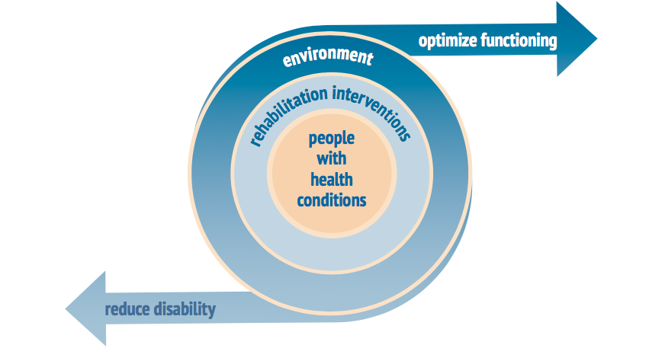

Health condition refers to disease (acute or chronic), disorder, injury or trauma. A health condition may also include other circumstances such as pregnancy, ageing, stress, congenital anomaly or genetic predisposition.
Rehabilitation interventions are targeted actions to build muscle strength, improve balance, cognitive ability or communication skills. This skill-building can assist people to perform basic daily activities, such as moving around, self-care, eating and socializing.
Rehabilitation also removes or reduces barriers in society through modification to people’s personal environments such as home, school or work to safely and efficiently move around.
In many countries, rehabilitation is closely associated with disability, and sometimes considered a disability service. However, rehabilitation is a health strategy for the entire population, including people with disability.
Rehabilitation is for all people, as part of the continuum of health care and within health systems. Rehabilitation is important at all levels of the health system (tertiary, secondary, primary and community). For additional information on rehabilitation please refer to Appendix A.

Health Trends and Rehabilitation Needs in Georgia

Georgia Country Context
Georgia’s country context is complicated with different information sources describing the country in slightly different terms. For the purposes of this report, Georgia consists of Tbilisi (capital), ten regions (including the Autonomous Republic of Adjara) and two occupied territories – Abkhazian Autonomous Republic and Tskhinvali /South Ossetia region (see map in Appendix C).
According to the 2014 population census, Georgia’s population is 3,713,804 of which 100,113 are identified as persons with disabilities (2.69%). The Census covered 82% (57,000 square kilometers) of the whole area of the country. The Census could not be carried out in the occupied territories: the Autonomous Republic of Abkhazia and South Ossetia (total area of 13,000 square kilometers). According to the Statistical Yearbook of Georgia 2019, the population is 3,723,500 (not including the occupied territories).
As of December 2018, Georgia has 293,000 internally displaced persons from conflict and violence.
There is significant out-migration of the working-age population. An estimated 0.75 million Georgians, or 16.6% of the population, have emigrated; the top destination country is the Russian Federation, followed by Ukraine and Greece (World Bank, 2016).
83.4 % of population of Georgia are Orthodox Christians, 10.7% -Muslims, and 2.9% belong to Armenian Apostolic Church.
Georgia is a developing country and ranks 70th on the Human Development Index.

Health context, trends and rehabilitation needs in Georgia
Health context or trends can serve as proxy indicators that may drive demand for rehabilitation services. In Georgia, health trends or contextual factors include the rise of non-communicable diseases (NCDs), an ageing population, the number of persons with disabilities, and those with difficulties functioning.
The rise of NCDs in Georgia
The main types of NCDs are cardiovascular diseases (like heart attacks and stroke), cancers, chronic respiratory diseases, and diabetes. In Georgia, NCDs are estimated to account for 93% of all deaths.
Figure 2. Mortality estimates in Georgia
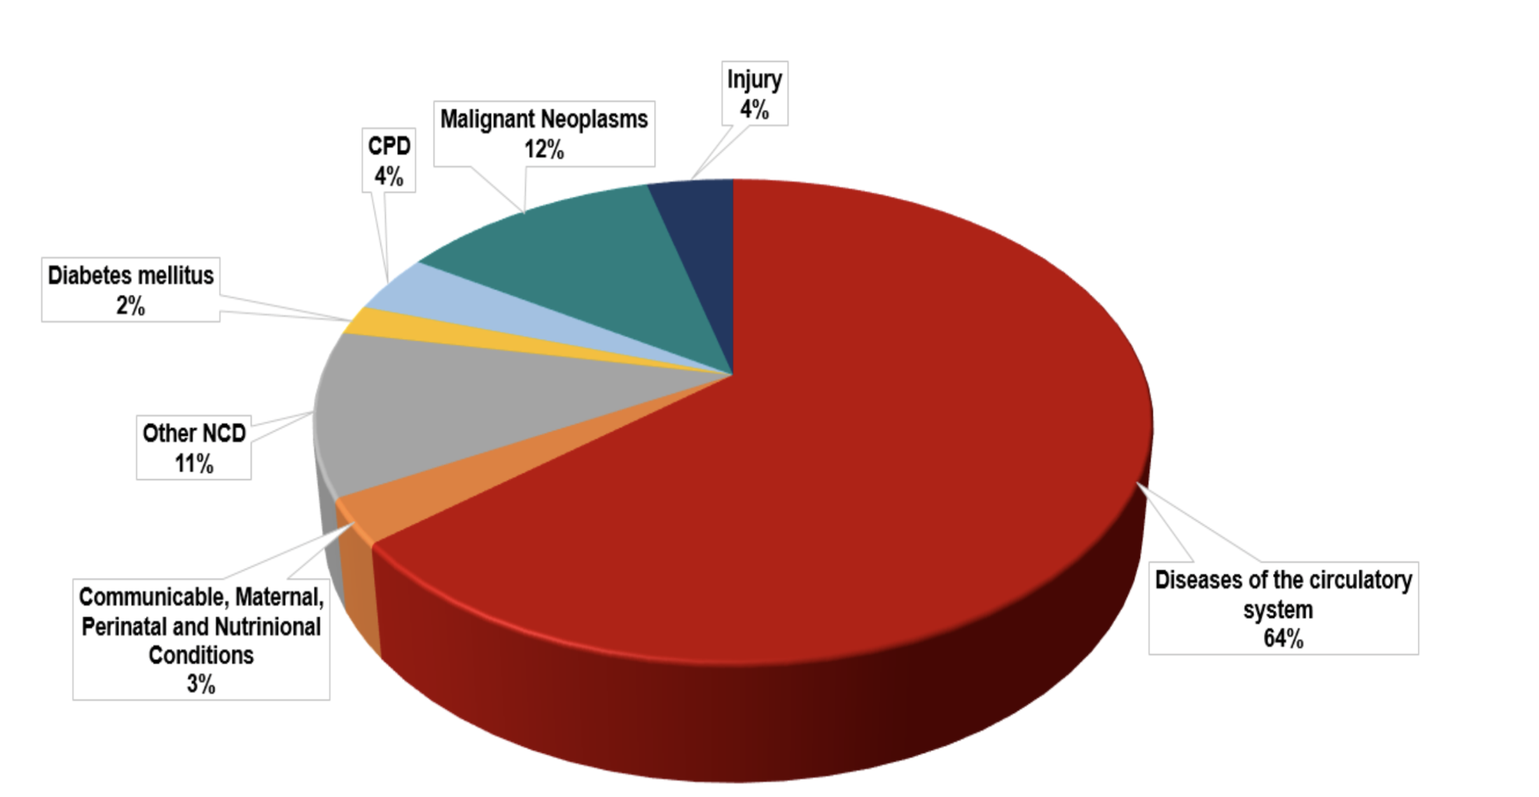
Georgia’s ageing population
According to the 2014 Census, 14% of people in Georgia are 65 and older. By 2050, this age group will grow to be 25% of the population. WHO is working to refine measures of healthy aging as part of their 10 Priorities for a Decade of Action on Healthy Ageing. The focus is on older people’s ability to function (functional ability) within their environment, not their age or the conditions or diseases they have.
Persons with disabilities in Georgia
Rehabilitation intersects with the disability sector, as persons with disabilities are a key population group who may benefit from rehabilitation. Georgia ratified the UNCRPD in December 2013 and officially joined the group of States Parties on 13 March 2014.
- Statistics on persons with disabilities living in Georgia are gathered by the National Statistics Office of Georgia (Geostat) within the framework of the general census of the population, and MoLHSA’s Social Service Agency (SSA) based on state allowances provided to persons with disabilities.
- The 2014 census showed that there were 100,113 registered persons with disabilities in Georgia (2.69%) while the SSA registered 118,651 persons with disabilities receiving social assistance as of 1 March 2015 (a difference of over 18,000 individuals). SSA figures increased to 125,104 in 2017. Information in Table 1 provides details comparing Geostat figures with SSA beneficiaries in 2017.
Table 1. Estimates of persons with disabilities in Georgia
Information Source | Total | Group I | Group II | Group III | Children
2014 Census | 100,113 | 26,784 | 58,255 | 9,902 | 5,172
2017 SSA Beneficiaries | 125,104 | 26,568 | 75,268 | 5,836 | 10,052
Disability determination Group I: Acute Group II: Considerable Group III: Moderate
- The disability status determination system in Georgia is based predominantly on the medical model of disability; the current system focuses on specific diagnosis, rather than the overall health state of a person and its impact on a person's daily functioning. UNICEF Georgia in close cooperation MoLHSA is implementing the pilot of the social model of disability assessment and status determination system in the Autonomous Republic of Adjara. More information is provided in Section 8.

Persons with difficulties functioning
In addition to collecting information on disability, the 2014 census also collected information on functioning. The number of people with difficulty functioning is 1,301,675 (35%). See Section 8.
In 2018 Georgia carried out a Multiple Indicator Cluster Survey (MICS) that identifies 28% of adults and children (ages 2-49) have difficulty functioning in at least one domain. See Section 8 for details.

Overview to Georgia’s Health System and Rehabilitation
In 1999, the Ministry of Health and Ministry of Social Affairs merged. Since then, areas such as labor, employment and Internally Displaced Persons (IDPs) from the occupied territories have been brought under the Ministry to form MoLHSA.
MoLHSA is accountable for the health of the population, oversight of the health system, the quality of health services and equity in relation to access to health care throughout the country. It also provides oversight for social programs supporting vulnerable populations.
Within the MoLHSA structure, the Policy Department coordinates issues related to rehabilitation (see Figure 3); Ms. Nino Jinjolava oversees rehabilitation-related issues within the Social Protection Policy Unit and Dr. Mzia Jokhidze has a similar function within the Health Policy Unit.
Figure 3. Structure and organization of the MoLHSA related to rehabilitation.
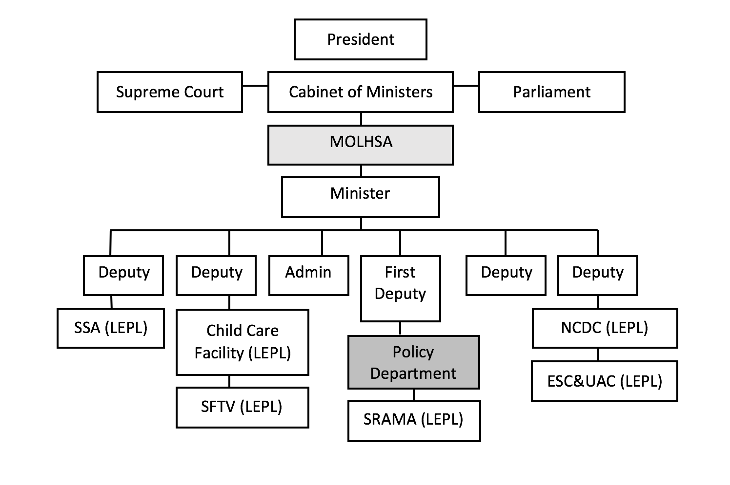

Legal Entities of Public Law (LEPLs) are independent bodies that carry out government functions. The key LEPLs within MoLHSA with linkages to rehabilitation within the health system are described in Table 2.
Table 2. Legal Entities of Public Law within MoLHSA related to health and rehabilitation
Name of LEPL | Acronym | Description of Rehabilitation-Related Function
Emergency Situations Coordination and Urgent Assistance Center | ESC&UAC | Ensures/coordinates quality emergency medical and referral assistance during disaster and martial law situations. It is also responsible for managing emergency calls (#112) ambulance services, and managing primary health care in villages.
National Centre for Disease Control and Public Health | NCDC | The main institution responsible for health statistics. It provides national leadership in preventing and controlling communicable and non-communicable diseases.
State Regulation Agency for Medical Activities | SRAMA | Responsible for issuing the licenses for medical activities and permits for health care facilities and pharmacies, and regulating medical professionals, pharmaceuticals and medical devices.
Social Service Agency | SSA | Responsible for purchasing publicly financed health services. The single payer in the health system for government-funded cover under the UHC and social assistance programs.
Agency for State Care and Assistance for the (statutory) Victims of Human Trafficking | SFTV | Protection, assistance and rehabilitation of victims of human trafficking, violence against women / or domestic violence, victims of sexual abuse.  Creating decent living conditions for people with disabilities, elderly, and orphaned children.

Georgia has experienced extensive health reform in the past fifteen years.
The health care system in Georgia is highly decentralized and was extensively privatized from 2007 to 2012. The main principles were to transition towards complete marketization of the health sector: private provision, private purchasing, liberal regulation and minimum supervision. The State retained control over a few medical facilities dealing with mental illness and infectious diseases, while all other hospitals and clinics were privatized. Approximately 84% of medical service providers are private.
The Government of Georgia introduced the Universal Health Care (UHC) Program in 2013. The UHC Program extends publicly financed entitlement to health care coverage to the entire population. The package covers a range of primary and secondary care services and limited essential drugs. More than 90% of the population are covered by the UHC program. UHC Program does not include rehabilitation services or assistive products.
Some standard indicators on health facilities and personnel are the number of health facilities, beds, doctors and nurses. Information for Georgia is provided in Table 3. Of note, the number of physicians is nearly double that of nurses and the rural doctors program represents 55% of outpatient facilities.
Table 3. Overview of health facilities and human resources in Georgia
Description | Number | Number per 100,000
Number of in-patient facilities | 273 | N/A
Number of hospital beds | 15,909 | 426.9
Number of physicians (including dentists) | 30,998 | 831.9
Number of nurses | 17,862 | 479.3
Number of out-patient facilities (includes rural figures)  - Rural physicians-entrepreneur | 2,283  1,267 | N/A

Other Stakeholders in Rehabilitation
In addition to MOLHSA, the other ministries that play a role in rehabilitation are the Ministry of Defense (MoD) and Ministry of Education, Science, Culture and Sport (MoES). The MoD manages The National Hero of Georgia Mariam (Maro) Makashvili Military Rehabilitation Center (see Section 9). The MoES houses the National Center for Educational Quality Enhancement (NCEQE); see Section 7.
Alongside private service providers, international organizations and non-governmental organizations also contribute to the rehabilitation landscape. Some key intervention areas include workforce capacity building (scholarships, in-country training and treatment protocols), provision of assistive products, facilitating dialogue, and other actions.
The donor landscape for rehabilitation in Georgia is varied. Donors identified during the assessment:
- USAID: Since 2005, USAID has invested nearly $10Million USD in disability and rehabilitation. Current programs: $1.2Million USD to UNICEF (2015-2020) and $4.5 Million to Emory University (2017-2021).
- Turkish Cooperation and Coordination Agency (TiKA): provides 300,000 GEL (~$100,000USD) to renovate the existing Rehabilitation Center for Persons Having Limited Ability Ltd. (Tbilisi).
- Federal Ministry of Economic Cooperation and Development (BMZ)-Germany: supports nurses training module for home care (9-year program and funding amount unknown).
- Private Investor: Ken Walker University Clinic for Medical Rehabilitation LLC (Tbilisi): $6 Million USD.

Rehabilitation Governance
Key Components | Status
Rehabilitation Legislation and Policies | There is no mention of rehabilitation in the current 2014-2020 health plan. Nearly all legislation and policies on rehabilitation are within a disability framework. Georgia ratified the UNCRPD in 2013. The “2018-2020 Government Action Plan for Human Rights Protection” references habilitation and rehabilitation services for persons with disabilities.
Rehabilitation Strategic Plan | Georgia has not yet developed a rehabilitation strategic plan.
Leadership and Coordination | Rehabilitation leadership focuses on guidance and financing for social programs. There is an interagency group focused on early childhood development (ECD) and three technical working groups (wheelchairs, adult rehabilitation, professional standards) linked to Emory University project.
Rehabilitation accountability and reporting | Outside the disability context, there is no reporting on rehabilitation. There is no evidence of information collected about performance of rehabilitation either within social programs or the health sector.
Regulatory Mechanisms | There are low levels of regulation that apply to rehabilitation and assistive technology. Licensing is only required for medical doctors. Pricing and guidance exists for some assistive products through social programs.
Assistive Technology (AT) Policies, Plans and Procurement | Leadership for assistive technology exists but all processes and management structure are housed within social protection. There are many gaps or deficiencies that require further attention. A formal AT Assessment (with support from WHO) is planned for Georgia in 2020.

Rehabilitation Governance and Regulatory Documents
Georgia’s current health plan, 2014-2020 State Concept of Healthcare System of Georgia for ‘Universal Health Care and Quality Control for the Protection of Patients’ Rights’, identifies ten priority areas for improvement. There is no mention of rehabilitation in the document. MoLHSA is currently engaging a consultant, Lajos Kovacs, to support the development of the National Health Strategy 2021-2026.
The Government of Georgia issues an annual State Program of Social Rehabilitation and Childcare. The goal of the program is to improve the physical and social conditions of persons with disabilities including children, the elderly, homeless, and socially vulnerable individuals and promote their social integration. The document outlines the approved sub-programs, source of funding, beneficiaries, program supervision, penalties and sanctions and program implementation period. Information on funding is in Section 6, and services provided in 2019 through this program are in Section 9.
Georgia ratified the UNCRPD in 2013; Article 26 references habilitation and rehabilitation. In 2017, Georgia drafted the Law on the Rights of Persons with Disabilities (not yet approved). Georgia’s 2018-2020 Government Action Plan for Human Rights Protection, approved by Decree #182 (17 April 2018), envisions an increase of accessibility to habilitation/rehabilitation services for persons with disabilities and children, with the evaluation indicator of defining the capacity for developing rehabilitation needs and services for adults (Article 19.1.6).
There are many policy documents pertaining to Early Childhood Development (ECD):
- Decree #282 by the Parliament of Georgia, on approving the national concept of Early Childhood Intervention (ECI) aimed at ECD (dated 9 February 2017);
- Decree #01-188/o by the Minister of Labor, Health and Social Affairs on approving the minimal standards for ECI (dated 18 August 2017);
- ECI sub-program of the State Program on Social Rehabilitation and Childcare.
- Decree #234 on the 2018-2020 national action plan for implementing national concept on ECI (dated 15 May 2018);
- Decree #01-66/o by the Minister of MoLHSA (20 August 2018) to establish an interagency working group to coordinate the implementation of the 2018-2020 national action plan for implementing national concept on ECI.

Rehabilitation Leadership, Planning and Coordination
Leadership for rehabilitation is historically grounded in MoLHSA’s social programs for persons with disabilities. Aside from guidance on the implementation of the State Program for Social Rehabilitation and Child Care, there is very little planning or detail on rehabilitation workforce or services.
Although MoD, MoES and MoLHSA each have a role in rehabilitation, there is little evidence of coordination across ministries. Conversely, coordination around ECD appears to be well established with an interagency group on ECD as well as a coalition of early intervention service providers.
Based on the decision of the Project Support Board within MoLHSA, three technical working groups were established in relation to the USAID-funded Physical Rehabilitation Project in Georgia. The 13-member Board is a cross-section of government, professional associations, international organizations and universities. The three technical working groups focus on: wheelchair service provision, policy on adult rehabilitation, and professional standards, licensing and educational programs within the project.

Rehabilitation Accountability, Reporting, and Transparency
Reporting on rehabilitation service delivery is at a low level and the status and performance of rehabilitation is not available or unknown.

Governance, Procurement and Regulation of Assistive Products
MoLHSA has not yet created a Priority Assistive Products list. The State Program for Social Rehabilitation and Child Care provides some guidance on pricing and supplier criteria for assistive products (especially wheelchairs). The existing guidance and current pricing merit review and the planned WHO-supported AT Assessment for mid-2020 is well-timed.
Specific to wheelchairs, the system of wheelchair service provision in the country is supervised by MoLHSA (responsible for the development of the policy and relevant sub-program) and LEPL-SFTV (responsible for the implementation of sub-program activities). In addition, a Wheelchair Service Provision Working Group has been set up in Georgia within the frames of the Physical Rehabilitation Project supported by Emory University. The Working Group implements the project activities in accordance with the action plan developed as part of the same project and is accountable to the Advisory Board of the Project - "Physical Rehabilitation in Georgia".

Summary of Rehabilitation Governance Situation
- MoLHSA demonstrates a commitment to rehabilitation through support and actions articulated in the annual State Program for Social Rehabilitation and Child Care.
- Leadership and coordination for rehabilitation is provided through the current MoLHSA Policy Department (Social Protection Policy Unit and Health Policy Unit).
- Georgia has ratified the UNCRPD and drafted a national disability law.
- In Georgia, rehabilitation and disability are deeply connected. Concerted effort is needed to disentangle them in order to emphasize and highlight that rehabilitation is part of the health care continuum and for anyone who needs it.
- There is little or no evidence of systematic coordination between government ministries on rehabilitation.
- There is no national plan for rehabilitation.
- There is no reporting on the status and performance of rehabilitation in health systems.
- There is limited evidence of accountability mechanisms between rehabilitation service providers and MoLHSA. Only the medical facilities where services are provided by rehabilitation doctors (licensed/certified for Independent Medical Practice) are accountable. Service providers submit monthly reports to the Agency on the work performed.
- Only medical doctors are regulated (professional competencies), and require a license (Certificate for Independent Medical Practice) to practice. This does not yet apply to any other members of the rehabilitation workforce.
- Early childhood development has many policy documents and coordination mechanisms.
- Assistive products are largely unregulated. The government has few guiding frameworks for the procurement and provision of assistive products.
- A list of Priority Assistive Products is not yet developed.

Rehabilitation Financing
Key Components | Status
Mechanisms for Rehabilitation Financing | Rehabilitation financing within MoLHSA is primarily for children and adults with disabilities. All other rehabilitation is paid by individuals; almost exclusively out-of-pocket (OOP).
Rehabilitation Expenditure | The three key budget lines for rehabilitation within MoLHSA’s social rehabilitation and child care for rehabilitation include:  ECD, assistive products, and habilitation/rehabilitation; the total budgeted amount is 12M GEL (~$4.3M USD). See Table 4.
Rehabilitation Expenditure as Proportion of Total Health Expenditure | The budget for social rehabilitation and child care represents less than 1% of the total MoLHSA budget. Of that one-percent, ~31% is budgeted for rehabilitation (as above).
Assistive Product Expenditure | According to MoLHSA 2020 budget, just over $2Million USD is available for assistive products (see Table 4).
Out-of-Pocket Costs for Rehabilitation | OOP payments for health care are over 50%. For adults without a disability determination OOP costs for rehabilitation would be nearer 100% as it is not covered under UHC and generally not part of insurance.

Mechanisms for Health (and Rehabilitation) Financing
In 2013 Georgia launched the UHC Program whereby the SSA reimburses providers according to agreed tariffs for specific conditions and procedures. By May 2017, the UHCP covered more than 95% of the population, based on the number of persons registered with a primary care provider. Rehabilitation and assistive products are not included in the UHC package.
In addition to UHC, the health budget also finances 23 vertical programs for priority diseases and conditions. The vertical programs include: mental health, diabetes management, child leukemia services, dialysis and kidney transplantation, palliative care, and a range of public health protection programs including tuberculosis control, vaccination programs and the innovative hepatitis C program.
Voluntary health insurance is also available in Georgia and represents 5-7% of the health budget.
In Georgia, out of pocket (OOP) payments constitute the main source of revenue (57%) for health care.

Figure 4. Health expenditure 2017 (CDC Statistical Yearbook 2018)

Public (38%): UHC or vertical programs
OOP (55%): Out of pocket
VHI (6%): Voluntary Health Insurance
Intl donor (1%): International donors
An additional source of financing is through municipal budgets. Each has the discretion to determine supplemental amounts for health care or social programs, and support for individuals is provided on a case-by-case basis. Information from municipalities was not collected during this assessment.
Table 4. MOLHSA 2020 Budget
BUDGET LINE | GEL | USD | % of TOTAL
Total government budget | 13,000,000,000 | 4,659,563,265 | 100
1. MOLHSA budget | 4,363,000,000 | 1,563,821,117 | 33.56
1.1. Population Health | 1,079,000,000 | 386,743,751 | 8.3
1.1.1. Universal Health Care | 757,136,000 | 271,421,517 | 5.8
1.1.1.2. Mental Health | 27,500,000 | 9,877,759 | .2
1.2. Social Protection | 3,126,000,000 | 1,120,996,145 | 24.04
1.2.1. Pensions | 2,230,000,000 | 799,420,425 | 17.2
Sub-divisions within Social Protection budget
1.2. Social Protection | 3,126,000,000 | 1,120,996,145 | 100
1.2.1. Pensions | 2,230,000,000 | 799,420,425 | 71.3
1.2.2. Social Rehabilitation and Child Care | 37,400,000 | 13,411,790 | 11.9
Sub-divisions within Social Rehabilitation and Child Care budget
1.2.2. Social Rehabilitation and Child Care | 37,400,000 | 13,411,790 | 100
1.2.2.1. Early Childhood Development | 3,200,000 | 1,147,776 | 8.55
1.2.2.2. Day Care Service Provision | 6,300,000 | 2,259,684 | 16.84
1.2.2.3. Assistive Products | 5,600,000 | 2,007,402 | 14.97
1.2.2.4. Habilitation and Rehabilitation of Children | 3,440,000 | 1,233,859 | 9.19
1.2.2.5. Sub-program to promote communication for the Deaf | 48,000 | 17,216 | .12
1.2.2.6. Sub-program to provide home care for children with severe and profound developmental delays | 252,000 | 90,387 | .67
1.2.2.7. Sub-program to provide home care for children with severe and profound disabilities or health problems. | 255,500 | 91,642 | .68

Adjara Autonomous Republic
The Ministry of Health and Social Affairs of Adjara Autonomous Republic has its own budget. The total budget amount for the Ministry is 21,000,000 GEL (~$7.6Million USD). Within this budget, there is a broad budget category of medical and social rehabilitation, 2,767,280 GEL (~$1Million USD) with sub-programs that resemble the MoLHSA budget.
One unique characteristic of the Adjara budget is an allocation for adult medical rehabilitation. This budget line, 600,000 GEL (~$216,000 USD) is found within general medical services (code 06 02) and not within the medical and social rehabilitation code (06 05). That said, funding is for adults with disabilities.

Payment Processes for Rehabilitation Treatments
Payment for rehabilitation is based on a pre-set number of treatments and/or vouchers with maximum budget amounts clearly articulated. In Georgia, payment for rehabilitation is for children under age 3, children (up to age 18) with disabilities, adults with disabilities, elderly, war veterans and other vulnerable populations. Criteria for eligibility is clearly articulated in multiple guidance documents.
For children (age 18 and younger), payments through SSA for one calendar year includes:
- 8 courses of treatment - 330 GEL (~$120 USD) maximum payment per course.
- Course duration is ten days (generally given over a one-month period).
- A maximum of 22 sessions (procedures or treatments) are provided within ten days.
In summary, a child is eligible for a total of 80 days of interventions that include up to a total of 176 treatments with a maximum SSA contribution of 2,640 GEL (~$950 USD) per calendar year.
In Adjara, rehabilitation payments for adults with disabilities in one calendar year includes:
- Two courses of treatment – 600 GEL (~$215 USD) maximum payment per course.
- There must be at least 15 sessions (procedures or treatments) – maximum one procedure/ day.
In summary, and adult with disability in Adjara is eligible for 30 days of interventions for a total ceiling of 30 treatments (procedures) with a maximum contribution of 1,200 GEL (~$430 USD) per calendar year.
For assistive products, SSA mails a voucher with the amount reimbursable by SSA. The individual takes this voucher to an approved service provider to receive the product.

Rehabilitation Expenditure
The projected 2020 rehabilitation budget within social protection is over $6 Million USD (see Table 4).

Assistive Product Expenditure
Budgeting and expenditure for assistive products is captured within the Social Protection budget under the sub-division within Social Rehabilitation and Child Care budget. The annual amount budgeted for assistive products is about $2 Million USD (see Table 5). Of this amount, nearly half is for prosthetics and orthotics, one-third for cochlear implants and just over 15% is for wheelchairs (with over 60% of the budget allocated for electric wheelchairs).

Table 5. MOLHSA 2020 Budget related to assistive products
Description | GEL* | USD | % of total
Assistive Products (as taken from Table 4) | 5,600,000 | 2,007,402 | N/A
Assistive Products (summary of budget lines below) | 5,848,500 | 2,445,534 | 100
Total budget for wheelchairs (120 electric/500 manual) | 934,200 | 336,830 | 16
Electric Wheelchairs (4,785 GEL / $1,725 per unit) | 574,200 | 205,588 | 61.5
Manual wheelchairs (720 GEL/ $259 per unit) | 360,000 | 131,242 | 38.5
Prosthetics/orthopedics (extensive price list provided) | 2,682,000 | 967,008 | 46
Hearing aids (1,400 digital hearing aids) | 378,000 | 136,289 | 6
Cochlear implants – 30 (per unit 39,500 GEL + rehab costs) | 1,854,300 | 668,577 | 32
Crutches, canes walking frames (no budget provided) | ? | ? | ?
Smartphones (for Deaf and hard of hearing individuals) | 6,000 | 2,152 | ?
*(Note: Total budget amount for assistive products is taken from the 2020-2023 Mid-term budget, while specific funding ceiling is provided from the 2020 State Program for Social Rehabilitation and Child Care. The total amounts may vary and thus the figures and percentages are illustrative.)

Out-of-Pocket (OOP) Costs for Rehabilitation
There is no detailed data available on the OOP costs for rehabilitation. As UHC does not cover this, it is likely that OOP costs for rehabilitation go far beyond the 55% OOP costs for health care services.

Summary of Rehabilitation Financing Situation
- Georgia’s UHC benefits ~95% of the population, but does not include rehabilitation.
- Approximately 84% of Georgia’s health service providers are private.
- The Government of Georgia allocates over $4 Million USD annually (through SSA) for rehabilitation services and products, but resources are primarily for children with disabilities within social programs.
- The Autonomous Republic of Adjara funds adult rehabilitation; this program is for adults with disability.
- MoLHSA (through SSA) provides ~$2 Million USD annually for a limited type and number of assistive products.
- The voucher system (payment for rehabilitation services and assistive products) specifies dosage, timeline and funding amounts for goods and services. This is irrespective of a individual diagnosis, need, or treatment outcomes from previous investments.
- Adults (without a disability) who need rehabilitation must pay out of pocket for services.

Rehabilitation Human Resources and Infrastructure/Equipment
Key Components | Status
Total Number of Rehabilitation Personnel | There are estimated 300 medical doctors with specialization in rehabilitation licensed /Certified for Independent Medical Practice; other rehabilitation personnel include: ~500 PTs, 25 OTs, ~1000 SLTs and logopeds, and ~10-15 P&O technicians (including bench workers).
Number of Rehabilitation Personnel per 10,000 Population | Data not centralized, consolidated or available. Some information is available for medical doctors.
Distribution of Rehabilitation Personnel Across Geographic Areas | Information available on rehabilitation doctors (see Table 12); no other information is collected at central level.
Licensure and regulations for rehabilitation personnel | Only medical doctors require a license / certificate and are regulated. No other rehabilitation personnel have this requirement.
Rehabilitation Infrastructure / Equipment | There are no minimum standards for rehabilitation equipment.

Rehabilitation Workforce Context in Georgia
Historically, rehabilitation in Georgia is linked to health resort therapy and massage. Rehabilitation workforce vocabulary includes some post-Soviet era terminology such as balneology (resort therapy) and rehabilitologist (may refer to a doctor specialized in rehabilitation or a physical therapist). Training programs focus on massage and therapeutic exercise. The large majority of logopeds (speech therapists) focus on speech development, phoniatrics, and correcting pronunciation.
The rehabilitation workforce training in Georgia is evolving. Medical doctors attain specialization in rehabilitation (through residency). In addition, there are accredited programs (Bachelor and Masters levels) in physical medicine and rehabilitation (PT), occupational therapy (OT) and language and speech therapy (SLT). These programs help elevate existing standards toward international norms.
Some key challenges in the health workforce are the lack of regulatory structures and competency frameworks to guide the professions (exceptions include medical doctors – physical medicine, rehabilitation and resort therapy). Continuing education is not a requirement in Georgia.

Rehabilitation Workforce Training
The MoES and MoLHSA are the two ministries involved in health workforce training.
The MoES oversees university education, training programs for undergraduate, masters and doctoral degrees, and houses the National Center for Educational Quality Enhancement (NCEQE).
The NCEQE is the only educational quality assurance body in Georgia established by the Law on Educational Quality Enhancement in 2010. The NCEQE is a LEPL under MoES. Its functions include:
- implementation of external quality assurance mechanisms of all educational institutions (higher education, vocational education, and general education) operating in the country,
- development and governance of the national qualifications framework; and
- recognition of foreign education.
The NCEQE oversees the National Qualifications Framework (NQF). This document unites all the qualifications existing in Georgia, reflects the learning outcomes of different levels of general, vocational and higher education - including what knowledge, skills, and responsibilities a person should have.
The NCEQE also oversees the classification of fields of study in Georgia.
Selected text from the classification of fields of study is in Table 6. PT is represented by the formal classification of Physical Medicine and Rehabilitation.
Table 6. Classification of fields of study in Georgia
09 Health and Welfare
091 Health
0915 Therapy and Rehabilitation (the study of restoring normal physical conditions to those incapacitated by temporary or permanent disability)
0915.1.1 Physical Medicine and Rehabilitation
0915.1.2. Occupational Therapy
0915.2.1. Language and Speech Therapy

Medical Doctors
MoLHSA regulates post-graduate specialized training for doctors. There are 27 main specializations for doctors. Physical Medicine, Rehabilitation and Resort Therapy and Sports Medicine are both captured under internal medicine.
MoLHSA Order No. 01-8/n (30 March 2015) details professional competencies for 31 medical specialties; this includes Physical Medicine, Rehabilitation and Resort Therapy but does not include Sports Medicine.
Medical doctors can attain specialization in rehabilitation through a 3-year residency program after 6 years of general medical education or an individual with an adjacent medical specialty (e.g. internal medicine) can retrain in physical medicine, rehabilitation and resort therapy through attending a several-month course (length is decided by a program director). These training opportunities are available only the Tbilisi State Medical University (TSMU). Both pathways require an individual to pass the State exam to obtain a license (Certificate for Independent Medical Practice).

Physical Medicine and Rehabilitation (Physical Therapy)
As noted previously, the formal classification for physical therapy in Georgia is called Physical Medicine and Rehabilitation. According to NCEQE information on accredited universities and graduates, there nine universities accredited to offer a Bachelor degree in Physical Medicine and Rehabilitation; four of them provide Master’s degree programs; see Table 7 for details. The number of graduates are below.
- NCEQE figures (non-shaded cells): BA – 507 and MA – 75
- University figures (shaded cells): BA – 670 and MA – 187
Annual estimates for future years is ~100 Bachelor-level and ~25 Master-level (conservative figures).
Table 7. Training programs in Physical Medicine and Rehabilitation in Georgia
Name of University / Program | Duration | Year Started | Accreditation Dates |  | Grads/  Year | Total Grads | On-going
Name of University / Program | Duration | Year Started | Start | End | Grads/  Year | Total Grads | On-going
1. Tbilisi State Medical University
BA (Georgian) | 4 years | 2008 | ? | ? | 50-65 | 337 | Yes
BA (English) | 4 years | 2008 | ? | ? | ~35 | 149 | Yes
BA | 4 years | ? | 11/28/2019 | 11/28/2026 | ? | 400 | Yes
BA | 4 years | ? | 09/06/2012 | 07/01/2020 | ? | ? | No
MA Pediatric Rehabilitation | 2 years | 2011 | 12/06/2019 | 12/07/2026 | ~4 | 23 | Yes
MA Sports Rehabilitation | 2 years | 2014 | 12/06/2019 | 12/07/2026 | ~8 | 22 | Yes
MA Rehabilitation Counselor | 2 years | 2011 | 10/21/2011 | 07/01/2020 | ~3 | 12 | Yes
2. Georgian State Teaching University of Physical Education and Sport
BA | 4 years | 2014 | ? | ? | 50-70 | 240 | Yes
BA | 4 years | 2014 | 07/22/2015 | 07/22/2020 | ? | 44 | Yes
MA | 2 years | 2014 | 05/19/2014 | 05/19/2020 | ? | 6 | Yes
MA (Georgian language) | 2 years | 2014 | ? | ? | 10 | 120 | Yes
3. Teaching University “Geomedi”
BA | 4 years | ? | 12/19/2019 | 12/21/2026 |  | 15 | Yes
MA | 2 years | ? | 12/19/2019 | 12/21/2026 | ? | 12 | Yes
4. Saint King Tamar University of Georgian Patriarchate
BA | 4 years | 2008 | 12/14/2015 | 12/14/2021 | ~6 | 21 | Yes
5. Batumi Shota Rustaveli State University (BSU)
BA | 4 years | 2013 | 08/27/2018 | 08/27/2024 | ~6 | 1 | Yes
6. Batumi Teaching University
BA | 4 years | ? | 03/19/2019 | 03/19/2025 | ? | ? | Yes
7. Akaki Tsereteli State University
BA | 4 years | 2018 | 06/28/2016 | 06/28/2023
8. New Vision University
BA Medical Rehab and Nursing (English) | 4 years | ? | 08/16/2016 | 08/16/2023 | ? | ? | Yes
MA Medical Rehab & Public Health Mngmt. (English) | 2 years | ? | 08/16/2016 | 08/16/2016 | ? | ? | Yes
9. Caucasus International University
BA (English) | 4 years | ? | 11/14/2018 | 11/14/2024 | ? | 26 | Yes
BA | 4 years | ? | 06/10/2014 | 06/10/2019 | ? | ? | No
BA: Bachelor of Arts
MA: Master of Arts

The Georgian State Teaching University of Physical Education and Sport – A History
The Georgian Institute of Physical Education and Sport opened in 1939. Among other faculties, the Faculty of Medicine and Rehabilitation admitted 200-300 students per year. In 1998, this university evolved into the Georgian Academy of Physical Education and Sport and had a curriculum of Physical Therapy and Rehabilitation with 500 students (including those from Turkey). In 2008 the entire facility closed, with students and faculty members absorbed by other universities. In 2014, the university re-opened as the Georgian State Teaching University of Physical Education and Sport. Graduates that precede the 2014 opening are not verified nor included in this report.

Occupational Therapy
In Georgia, OT training is offered only at Ivane Javakhishvili Tbilisi State University. Key dates are below.
- 2001: Two individuals graduate from a 3.5-year OT program.
- 2001-2005: (Tempus Project), 13 graduates (8 in the first cohort and 5 in the second cohort).
- 2006: Tbilisi State University launches the 4-year BA program.
- 2011: World Federation of Occupational Therapists (WFOT) approves curriculum.
- 2006-2020: 26 individuals graduate (approximately 2-3 students per cohort).
There are approximately 25-26 people with a BA in OT in Georgia and currently there are 15 students training for their BA in OT. Summary information on training in OT is in Table 8.
Table 8. Occupational Therapy training program in Georgia
Name of University / Program | Duration | Year Started | Accreditation Dates |  | Grads/  Year | Total Grads | On-going
Name of University / Program | Duration | Year Started | Start | End | Grads/  Year | Total Grads | On-going
Ivane Javakhishvili Tbilisi State University
BA | 4 years | ? | 09/16/2011 | 07/01/2020 | ? | 16 | Yes
BA | 4 years | 2006 | ? | ? | 2-3 | 26 | Yes

Language and Speech Therapy
Ilia State University (ISU) is the only accredited training institution to provide language and speech therapy training in Georgia. It began offering a 2-year MA degree in 2017. There are 8 graduates in 2019, expected 11 graduates in 2020 and 10 in 2021. Every year, ISU can accept up to 15 students. At present there is no BA program, but ISU is hoping to initiate this in the coming years. Summary information on training in SLT is in Table 9.

Table 9. Language and Speech Therapy training program in Georgia
Name of University / Program | Duration | Year Started | Accreditation Dates |  | Grads/  Year | Total Grads | On-going
Name of University / Program | Duration | Year Started | Start | End | Grads/  Year | Total Grads | On-going
Ilia State University
MA | 2 years | ? | 08/19/2016 | 08/19/2023 | ? | 7 | Yes
MA | 2 years | 2017 | ? | ? | 8-10 | 8 | Yes
In addition to ISU’s Master’s level SLT program, there are other pathways for Georgians to receive speech therapy training. The information below is illustrative.
- Through professional development institutes (in Russia) in the 1960s; unknown number of graduates.
- Pedagogic University provided a “defectology correction” program that had sub-programs for speech (logopeds and oligophreny). The program ended in 2002 with an estimated ~70-90 graduates.
- Private training facility (EMTA) provides ~60 hours of training and has trained over 100 people.
- Logomedi, founded by Mzia Putkaradze. In 1967, one-year courses were available, currently there is a 6-month course with 20-25 graduates per year.
Prosthetics and Orthotics
Currently in Georgia, there is no recognized training program in Prosthetics and Orthotics (P&O).
At the end of the 1990’s, the International Committee of the Red Cross (ICRC) supported a 3-year training course for Category II P&Os (see Table 10 for P&O category description) at the Georgian Foundation for Prosthetic Orthopedic Rehabilitation (GEFPOR). After coursework was complete, representatives from the International Society for Prosthetics and Orthotics (ISPO) came to Georgia to conduct exams; 5 graduates received certification and 4 have emigrated to other countries.
Table 10. ISPO-recognized Categories in Prosthetic & Orthotics
Category I P&O: 4-year training in prosthetics and orthotics (offered in multiple countries).
Category II P&O: 3-year training in prosthetics and orthotics.
Category II Prosthetics (single discipline): 18-month training in prosthetics.
Category II Orthotics (single discipline): 18-month training in orthotics.
Bench worker: Mixed levels of training and experience; most is on-the-job.

The Rehabilitation Center for Persons Having Limited Ability (Georgia MoD) has 10 P&O staff:
- three staff have had 3-year training in Armenia (1995-1998) – possible Cat II(?);
- four staff have been certified by Ottobock (unknown level).
Other training in recent years has been ad hoc and supported by Ottobock or by the U.S. Government.
In summary, there is only one ISPO-recognized Cat II P&O in Georgia. There are multiple other levels of training, but qualifications are difficult to determine with the information provided.

Psychologists
There are at least 14 universities that offer general psychology courses with over 2,000 graduates. There is only one program (TSU) that offers a Master’s Degree in Clinical Neuropsychology. During discussion on SLT, it appears that neuropsychologists are involved in adult SLT (addressing aphasia after stroke). The TSU program began in 1998. There are 14 graduates from the TSU MA Program.

Wheelchair Provision
Since 2010, at least ten trainings have been held in Georgia using WHO’s Wheelchair Service Training Packages. The Latter-Day Saints Charities (LDSC) have trained nearly 70 people using a shortened version of the WHO training package. A summary training dates, levels and participants is in Table 11.
Table 11. Number of people trained in wheelchair provision (using WHO training packages)
Dates | Basic | Basic/  Intermediate | Intermediate | Advanced | Training of Trainers
 |  |  |  |  | Basic | Intermed. | Advanced
8-12 March 2010 | 4
21 June-2 July 2010 |  | 5
1-10 February 2011 |  |  |  | 5
19-23 September 2011 |  |  |  |  | 4 | 3 | 3
26-30 September 2011 | 7
3-14 October 2011 |  |  | 4
2-12 April 2012 |  |  |  | 2
22-26 October 2012 | 5
21 June-3 July 2013 | 6
17 Oct-6 Nov 2013 |  |  | 4
SUB-TOTAL | 22 | 5 | 8 | 7 | 4 | 3 | 3
LDSC 2010-2019 | ~70 | Not data on the number of individuals currently providing wheelchairs.
TOTAL TRAINED | 92 | 5 | 8 | 7 | 4 | 3 | 3

Nursing
Nurses in Georgia are trained in 2-year or 3-year vocational schools across the country. Since 2011, nursing education has also been provided as a baccalaureate program in universities. There is no specialization such as rehabilitation nursing.
Caritas Georgia provides a training module (~100 hours) on home care for nursing students. Caritas has a memorandum of understanding with 28 colleges from which 8 send students to Caritas for training. There are 10-20 students per course and approximately 400 per year. To date, Caritas has trained about 2,800 nursing students in home care.
Caritas provides (or plans to provide) other training programs relevant to rehabilitation:
- Rehabilitation module (42 hours) – about 100 people trained.
- Educational program for caregivers – not yet implemented; to start at end of 2020.

Pre-Service Education - Clinical Practice
The assessment does not examine details on workforce pre-service training (curriculum content, theory vs. practice and clinical supervision and guidance). Many facilities have agreements with universities to serve as clinical sites for pre-service training. The educational institution sets requirements on performance evaluation forms and selects clinical mentors for students’ clinical practice.
Evidence of good practice and promising future developments supporting clinical practice include:
- TSMU’s clinical practice assessment form (extremely thorough).
- Caritas’ mentorship course to help medical professionals become better clinical mentors (2021).
- Discussion on the use of the Objective Structured Clinical Exam (OSCE) in Georgia and including rehabilitation as one of the professional fields to be included.

Licensing, Regulation and Continuing Medical Education
Within MoLHSA, the SRAMA is responsible for regulating medical facilities and professionals. Only medical practitioners (doctors) are required to have a license (Certificate for Medical Practice) to practice – no other health professionals have a licensing requirement. A license is issued after passing a national exam and is valid for life.
MoLHSA regulates only medical activities and has professional competencies for medical specializations. Within MoES, NCEQE has classified fields of study for PT, OT and SLT but has not yet completed the NQF for these professions. A working group on professional standards and licensing has been established within Emory University’s Physical Rehabilitation Project in Georgia.
There is no continuing medical education (CME) requirement for health professionals working in the field of rehabilitation in Georgia.

Rehabilitation Workforce Numbers and Locations
In Georgia about 300 doctors have permission to engage in independent medical work under the specialty of Physical Medicine, Rehabilitation, and Resort Therapy. Data on their employment is provided in Table 12.
Table 12. Number of rehabilitation doctors by location in Georgia.
Location | Rehabilitation Doctors
Adjara | 15
Guria | -
Tbilisi | 84
Imereti | 5
Kakheti | 3
Mtskheta-Mtianeti | -
Racha-Lechkhumi and Kvemo Svaneti | -
Samegrelo | 6
Samtskhe-Javakheti | -
Kvemo Kartli | -
Shida Kartli | 1
TOTAL (in Georgia) | 114

Although there is no consolidated data about numbers and locations of PTs, OTs and SLTs working in Georgia, the following estimates are provided from discussions during the in-country assessment.
- Physical Medicine and Rehabilitation (PTs): Over 500 working in the country.
- OTs: Approximately 25 in the country.
- SLTs (and Logopeds) – over 1,000 with a high variety of qualifications.
- P&O technicians: ~10-15 (including bench workers).
- Audiologists: ~10-12 in the country.

Professional Associations
There are multiple rehabilitation-related professional associations in Georgia. For some professions, there is more than one association. In addition, the name of an association may not accurately represent the membership. Details are provided in Table 13.
Table 13. Rehabilitation-related associations in Georgia.
Name of Association | Acronym | Date Created | Members | Member Description | International  Affiliation
Georgian Physical Therapy Association | GPTA | 2003 | ~120 | Doctors with specialization in rehabilitation | European Society of Physical and Rehabilitation Medicine (ESPRM)
Georgian Association of Physical Medicine and Rehabilitation | GAPMR | 2019 | Focal point: Avtandi Khmiadashvili
Georgian Physical Therapy and Rehabilitation Association | GAPTAR | 2017 | ~200 | Physical therapists and physical therapy students | World Confederation for Physical Therapy  (WCPT)-2019
Georgian Physical Therapists Association | GPTA | 2017 | ~150 | Active and non-active physical therapists | Not yet - hoping to join WCPT.
National Association of Medical Rehabilitation and Sport Medicine | ? | 2012 | Focal point: Dimitri Tsverava
Georgian Occupational Therapists’ Association | GE-OTA | 2004 | ~40 | Occupational Therapists | World Federation of Occupational Therapists (WFOT)-2016
Georgian Speech and Language Therapy Association | GSLTA | 2019 | ~105 | Speech therapists and logopeds | None
Speech Therapist Association of Georgia | ? | 2010 | Focal point: Nino Maghlakelidze
Language and Speech Therapists’ Association | EMTA? | 2018 | 30~ | Khatuna Kobakhidze | Want to join European International Association of Language and Speech
Georgian Speech and Language Therapist Association | ? | 2017 | Focal Point: Tinatin Antidze
Georgian P&O International Association |  | 2011 | Focal point: Guta Vashadze

Remuneration
In general, salaries for health care personnel are determined by their employers – the managers of the health care facilities where they work. Payment is negotiated on an individual basis between health care personnel and facility managers and can be based on workload or an agreed salary, or have elements of both. Primary care doctors working under the Rural Doctors’ Program are contracted by MoLHSA and paid a monthly salary.

Rehabilitation Infrastructure/Equipment
There is no list of essential rehabilitation equipment or materials required at different levels of care.
The purchase of medical equipment is the responsibility of hospital managers and the decision is linked to the availability of finances as most hospitals are private enterprises. Current regulations do not set a national ceiling of units per population for high-technology equipment.
From site vists conduted during the assessment (see Appendix D), all rehabilitation centers, units or departments had at least one or more ultra-sound, thermal, or electrotherapeutic machines. Treatment plinths or mats to facilitate functional movements and activities were less evident. Therapeutic swimming pools were identifed in 1/3 of the sites visited.

Summary of Rehabilitation
Human Resources and Infrastructure/Equipment Situation
- Nomenclature of rehabilitation workforce is linked to the classification of field of study in Georgia. Some existing vocabulary may be out-of-sync with terms commonly applied at international levels (example: physical therapy in Georgia is called physical medicine and rehabilitation).
- PT and SLT training programs have a long history in Georgia. Graduates of different programs have variable skills and competencies.
- Licensing is not required for PT, OT, SLT. Competencies and regulatory standards for these professions have not yet been developed in Georgia.
- A working group on professional standards and licensing is established through the Physical Rehabilitation Project in Georgia, supported by Emory University.
- There is no P&O training in Georgia and no recognized P&O Cat I in the country.
- There are many professional associations representing the rehabilitation workforce. Some professions have more than one association (PT and SLT each have 2-3) which leads to potential confusion between, or duplication of, organizational mandates.
- There is a lack of comprehensive, consolidated, and up-to-date information on numbers and locations of the rehabilitation workforce working in Georgia.
- There are no standard salaries for the rehabilitation workforce. These are negotiated with individual employers and largely based on income from treatments provided.
- Continuing medical education is not required for any health staff in Georgia.
- Medical doctors are regulated and require a license to practice (Certificate for Independent Medical Practice). Once granted, a license is valid for life.
- Lack of uniformity and standards in rehabilitation-related pre-service clinical training. There are wide variations in the expectations and guidance between and among training institutions and clinical placement sites.
- Georgia has a well-documented workforce of wheelchair providers.
- The rehabilitation infrastructure (equipment and treatment space) varies; there is no guidance on minimum standards for rehabilitation equipment.

Rehabilitation Information
Key Components | Status
Data on Disability, Rehabilitation Needs, and Population Functioning | The 2014 census and the 2018 MICS collect data on disability and functioning. A Model Disability Survey is planned for 2020.
Data, Digitalization and Georgia’s Health Information Systems | Annual reports from health facilities sent electronically to NCDC.
Data on Availability/Utilization of Rehabilitation | Very limited information from health system data on the availability or utilization of rehabilitation.
Data on Outcomes, Quality and Efficiency of Rehabilitation | There is no centralized data, and very limited information on outcomes, quality and efficiency of rehabilitation.
Data-driven Decision Making | There is no active planning of health personnel.
Government Funding for Rehabilitation Research | Outside of education institutions, there is very limited research on rehabilitation in Georgia.

Data on Disability, Rehabilitation Needs and Population Functioning
To attain reliable information regarding how well a population is functioning, the government must integrate a detailed ‘functioning module’ into a health survey or where possible, undertake a dedicated functioning and disability survey.
Within the 2014 Census, Georgia collected data on population functioning and disability based on the Washington Group questions. The two questions from the 2014 Census are in Figure 5.
Figure 5. Questions from the 2014 census related to disability
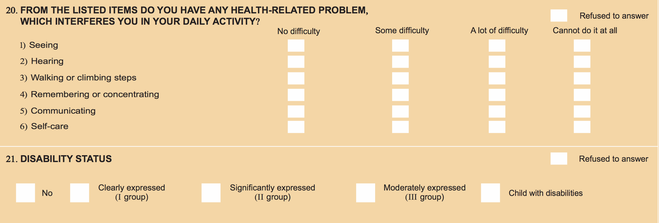

The number of people in Georgia with a disability is 100,113 (2.69% of the population); details are summarized in Table 14.
Table 14. Number of people identified with disability status (2014 census)
Total | Group I | Group II | Group III | Children
100,113 | 26,784 | 58,255 | 9,902 | 5,172

The number of people with difficulty functioning is 1,301,675 (35% of the population); see Table 15 for summary information, and Annex E for details.
Table 15. Number of people who identified any difficulty in functioning (2014 census).
Summary of six domains | Description of Limitation |  |  | Total
Summary of six domains | Some difficulty | A lot of difficulty | Can’t do it at all | Total
Number of people | 977,633 | 264,966 | 59,076 | 1,301,675
Percent | 26.3% | 7.13% | 1.59% | 35%

In 2018, Georgia carried out a Multiple Indicator Cluster Survey (MICS) that identifies 28% of adults and children (ages 2-49) have difficulty functioning in at least one domain. See Table 16 for details.
Table 16. Number of people with difficulty functioning (2018 MICS).
Age group | Sex | Number Surveyed | Percent with difficulty functioning in at least one domain
2-4 years | BOTH | 1,606 | 1.8%
5-17 years | BOTH | 5,827 | 9.5%
18-49 years | Male | 2,455 | 6.8%
18-49 years | Female | 6,488 | 9.9%
2-49 years | BOTH | 16,376 | 28%

Disability Status Determination
- The disability status determination system in Georgia is based predominantly on a specific diagnosis, the International Classification of Diseases (ICD-10), and is grouped into three categories: Level I, II and III. Since 2008, the Government of Georgia selects facilities eligible to determine disability status. There are approximately 70 facilities authorized to determine disability status; 23 in Tbilisi. Disability status is important to determine eligibility for state allowances – social package and is a requirement to access SSA payment vouchers for designated rehabilitation services and assistive products.
Disability status determination is influenced by age (over age 18) and diagnoses (some must be assessed annually, while others are a determination for life), and onset of the problem (waiting period of six months after onset of condition). Disability status determination is not based on function.
In 2017, UNICEF Georgia, in close cooperation MoLHSA and the Georgian Association of Social Workers, began developing a social model of disability assessment and status determination system. The pilot project in six medical facilities in Adjara runs from April 2019-May 2020. To date over 600 people have joined the pilot (including 250 children). There is a parallel pilot project in three clinics in Akhaltsikhe (Nov 2019-June 2020). The premise of these pilot projects is to compare disability status determination using the current medical model with the piloted social model of disability status determination. Data analysis on differences may serve as a foundation for future decision-making on disability determination.

Data, Digitalization, and Georgia’s Health Information System
In 2011, USAID published a document: Georgia Health Management Information System Strategy “Healthy Georgia, Connected to You”. The document details how MoLHSA will implement a new comprehensive Health Management Information System (HMIS) to interconnect the information needs of the Ministry, insurers, providers and patients. There is no information on the status of this program.
Between 2014 and 2016, new technologies of data reporting have been gradually introduced in Georgia. Electronic reporting systems were launched for all inpatient and outpatient health facilities providing services countrywide, including under the UHCP and vertical programs.
Each year, the NCDC collects information from all medical facilities. The two main forms discussed during the assessment are Form #01 (facility information and statistics on staffing structures) and hospital registration Form #066 (provides information on patients – diagnosis and treatments). Within the NOMESCO Classification of Surgical Procedures (NCSP), there is a chapter on rehabilitation and nursing care (Code R). NCDC requests hospitals to provide up to 3 major surgical procedures and 3 or more diagnostics or therapeutic procedures. During the years 2018-2019, there was only one report of “other rehabilitation procedure” (R4R160).

Data on Availability /Utilization of Rehabilitation
There is no consolidated data on the availability and utilization of rehabilitation in Georgia.
Individual facilities collect information on treatments provided but there is no uniform data set or standardized forms between facilities.
Two initiatives provide information on the availability of rehabilitation. The first is a hard-copy pamphlet called the Akhaltsikhe Municipal Social and Health Services Guide. In 2013, the Akhaltsikhe Municipality and five partner organizations (with funding from the European Union) created a pamphlet that outlines available services in the municipality with the following format:
- Name of service
- What kind of support provided by the service?
- For whom is the service intended?
- Who provides the services?
- What steps do I need to take to get a service (what documentation to submit)?
- Contact information
The second initiative is a planned electronic mapping of service providers; being developed by MAC Georgia.

Data on Outcomes, Quality and Efficiency of Rehabilitation
There is no consolidated data on the outcomes, quality, and efficiency of rehabilitation in Georgia.
Summary of Rehabilitation Information Situation
- The 2014 Census lists 100,113 people with a disability (2.69% of the population) and identifies 1,301,675 people (35% of the population) have difficulty functioning.
- The 2018, MICS (16,376 people, age 2-49 years) notes 28% percent of those surveyed have difficulty functioning.
- Information on work locations of medical doctors is collected and available.
- There is no collated nor centralized information on work locations of PTs, OTs, SLTs.
- There is no centralized data available on names and locations of health facilities that provide rehabilitation services.
- Determination of disability status is based primarily according to ICD-10 diagnosis. There are two pilot programs to determine disability incorporating functioning. Tools have been developed by UNICEF and the initiative funded by USAID Georgia.
- There is no data collected on outcomes, quality, or efficiency of rehabilitation services.
- Data driven decision making is not a common practice related to workforce planning in the field of rehabilitation.
- There is very little research on rehabilitation in Georgia.

Rehabilitation Service Accessibility and Quality
Key Components | Status
Percentage of tertiary and secondary hospitals with rehabilitation services | Consolidated and centralized data is not available.
Percentage of districts/communities covered by rehabilitation services | Consolidated and centralized data is not available.
Number of specialist rehabilitation facilities/units | One specialist rehabilitation facility (pulmonary), and ~ 10 that focus on rehabilitation (see narrative and Table 7).
Number of rehabilitation beds, and rate per 10,000 populations | Estimates of ~130 rehabilitation bed capacity in the country  (see Table 7).

Overview of Rehabilitation Service Accessibility
Consolidated and centralized data on the location of rehabilitation services in Georgia is not available. Although NCDC collects annual data from health facilities, information on rehabilitation is not included. Most health service providers Georgia are privately managed and have their own staffing structures and operating systems. UHC covers treatment procedures and hospital stays (not rehabilitation).
In Georgia, availability of rehabilitation is weighted toward children with disabilities with services funded through social program budgets. An adult with disability may be eligible for some rehabilitation services and products but the clear majority of adults needing rehabilitation must pay OOP for any intervention.
The assessment team visited ~15 health service and rehabilitation providers (public and private), but did not visit any balneology (health resort) facilities. Main findings are in this section. This does not represent all services and further investigation is needed.

Rehabilitation in Health facilities
In general, rehabilitation treatments are grouped into three main categories: physio procedures (generally these represent machines to deliver electrotherapeutic, iontophoresis, light, thermal and ultrasound treatments), medical massage, and medical exercises.
Two polyclinics seen during the assessment each have one licensed doctor specialized in rehabilitation who is delivering physio procedures for adults and children. All payments are OOP.
Larger private companies (Aversi, Evex, PSP-New Hospitals) each have a specialized unit or rehabilitation center as part of their network. Aversi notes that 5 of their 11 clinics nationwide offer rehabilitation (one is a formal rehabilitation center while four clinics have one PT on staff).

Rehabilitation Case Study: awareness on and incentives for in-patient wards
Dr. Nino Kervalishvili has a PHD in cardiology and specialization in rehabilitation. She works in Aversi Clinic for over ten years. During this time, she provides awareness training on rehabilitation to medical doctors in the Aversi in-patient wards. The monthly trainings have evolved to 2-3 times per year as many doctors understand and prescribe rehabilitation – especially for post-surgical cases. Although payments for rehabilitation are still OOP, Aversi offers reduced rates on rehabilitation for in-patients.

Rehabilitation for Children
Within MoLHSA, rehabilitation for children is available through three social sub-programs: ECD, rehabilitation/habilitation and day care.
According to MoLHSA, 29 organizations provide ECD services for 1300 beneficiaries in 13 municipalities (Tbilisi, Kutaisi, Telavi, Zugdidi, Lagodekhi, Kobuleti, Batumi, Marneuli, Akhaltsikhe, Gori, Borjomi, Rustavi, and Zestaponi). The ECD program includes children up to age 7; children younger than 3 years do not need to have a disability to be accepted into the program.
MoLHSA notes there are 22 organizations that provide services within the children’s rehabilitation / habilitation sub-program. Services can be offered in the home, within day-care centers, or in rehabilitation centers/clinics. Organizations must be registered as a provider; a ministerial order provides guidance on requirements to be a service provider but there are no standards. There are 1500 children enrolled nationwide, the majority receive services at rehabilitation centers.
Day care centers are for vulnerable children (619 children) and for children with disability (1059 children) as well as for children with severe and profound developmental delays (58 children). There are 37 day-care centers for children with disabilities (ages 6-18 years old). In addition, there are day care centers for adults with disabilities (781 adults).

Rehabilitation in the Community
Georgia offers some home-based care programs for children with severe disabilities. Four service providers in three locations (Tbilisi, Zugdidi and Telavi) provide rehabilitation care for 70 children. As for community based rehabilitation (CBR), some municipalities have a budget for home care.
Since 1996, Caritas provides home care services through trained nurses in six locations in Georgia (Tbilisi, Gori, Kutaisi, Batumi, Akhalsike, and Ozurgeti). Rehabilitation is one component of home care. Caritas has translated the Home Care Manual written by Ingeburg Barden to Georgian. In it there is information on exercise, movement, activities of daily lining and products to increase functioning.

Specialized Rehabilitation Facilities
The assessment team visited nine facilities that have a specific focus on rehabilitation (see Table 7). Information in this section highlights information from four centers that have in-patient beds. Each has its own strength in providing rehabilitation services. That said, there is little focused attention toward sharing best practices, tools or experiences across rehabilitation service providers in Georgia.

Lung Disease Rehabilitation Center (Abastumani)
- Opened October 2019; it is the only hospital in Georgia operating as a rehabilitation hospital.
- Guidelines and protocols for pulmonary rehabilitation were approved on 21 February 2020.
- Government funds 100% of in-patient care (individuals can have up to 20 in-patient days per year).
- The National Tuberculosis and Lung Center in Tbilisi is the main patient referral site.
- Target groups: persons with disability with lung disease, IDPs, war veterans, socially vulnerable and people working in dangerous occupations – following the 2018 government-approved list.
- The rehabilitation has 100 bed capacity; but has 60 patients total since October 2019.
- The government provides 126,000 GEL (~$40,000 USD)/month.
- Rehabilitation staff: 2 doctors, 1 PT and 4 nurses.

The National Hero of Georgia Mariam (Maro) Makashvili Military Rehabilitation Center
- Original center opened in 2014; new $4.5 Million USD center officially opened 27 January 2020.
- Target group – wounded warriors on long-term convalescent leave.
- There are 530 beneficiaries (270 from Georgia and 264 from Ukraine); 529 men and one woman.
- Currently there is accommodation for 17 wounded warriors and their care-givers.
- Treatment is provided in 2-week rotations; to date, Georgian beneficiaries have had 74 rotations while Ukraine has had 17 rotations.
- MoD funds the center; all care and transport to and from the center is provided free of charge.
- Clinical rotations are available for students studying psychology.
- Staff (all paid by MoD): 4 case managers, 1 MD rehabilitation specialist, 4 PT, 2 OT, 3 psychologists.

PSP-New Hospitals in-patient rehabilitation Department
- New Hospital has the only in-patient department in Georgia for neuro-rehabilitation.
- The department is linked to the neurology unit and opened in mid-2019.
- There are five dedicated rooms (with additional bed for caregiver), and four additional beds available in the acute neuro unit if needed.
- Patients must come with a family member or designated care-giver.
- All payments are OOP.
- Staff: 2 neurologists,1 nurse, 1 assistant nurse, 6 PTs (other departments can use), no OT or SLT.
- Out-patient rehabilitation is also offered and the unit has 5-6 patients per day (all OOP).

Ken Walker University Clinic for Medical Rehabilitation LLC (Tbilisi)
- The 9-floor clinic will open in March 2020; 6 floors are for adults and 3 are for children.
- The clinic is on land provided by TSMU and it is functionally linked to TSMU’s First University Clinic.
- In March, there are 12 beds for adults. Ultimately, there are 48 beds for adults and children.
- Target staffing structure: 7 MDs, 35-40 PTs, 7 OTs, 3 psychologists and nursing staff.
- All payments for adults are OOP; treatment for children may be covered by social programs.
- The team visit on 20 February was prior to opening and construction was still on-going. The clinic will be opened in March 2020, with services and staffing structures phased accordingly.

Table 7. Specialized rehabilitation facilities and number of beds.
No. | Name | Location | Public/  Private | Beds | Rehabilitation Staff
 |  |  |  |  | MD | PT | OT | ST | Psy
1. | Lung Diseases Rehabilitation Center | Abastumani | Public  (MoLHSA) | 100* | 2 | 1 | 0 | 0 | 0
2. | The National Hero of Georgia Mariam (Maro) Makashvili Military Rehabilitation Center | Tserovani | Public  (MoD) | 17* | 1 | 4 | 2 | 0 | 3
3. | David Tatishvili Medical Center  (Health Palace) Rehabilitation Department | Tbilisi | Private | 0 | 2 | 26 | 0 | 1 | ?
4. | PSP-New Hospitals  In-patient rehabilitation Department | Tbilisi | Private | 5* | 1 | 6 | 0 | 0 | 0
5. | Ken Walker University Clinic for Medical Rehabilitation LLC | Batumi | Private | 0 | 3 | 3 | 0 | 1 | 2
6. | Ken Walker University Clinic for Medical Rehabilitation LLC | Tbilisi | Private | 12* | 8 | 35 | 7 | 7 | 3
7. | Aversi Rehabilitation Center | Tbilisi | Private | 0 | 2 | 6 | 0 | 0 | 0
8. | Chakvi Neurorehabilitation Center (Evex) | Batumi | Private | 0 | 2 | 9 | 0 | 5 | 15
9. | Neurodevelopment Center | Tbilisi | Private | 0 | 4 | 15 | 2 | 8 | ?
*100 bed capacity, but in 3 months the center has a total of 60 patients.
*17 patient beds, plus equal number for care-givers; look to expand to 50 beds in the future.
*5 patient beds plus equal number for care-givers; can increase patient beds to 9 if needed.
*12 beds for adults planned for March 2020, but plan a total of 48 beds for children and adults in the future.

Vision and Hearing
In 2018 MoLHSA mandates hearing screening for all newborns with a target of 95% coverage. A finite number of hearing aids and cochlear implants are funded and available through MoLHSA’s social programs. Eye glasses are available in main hospitals and funding is OOP.

Assistive Products
Assistive products are available through private pharmacies (OOP payments), providers approved by MoLHSA/SSA, and charitable donations. MoLHSA/SSA funds 11 types of assistive products.
MoLHSA provides variable guidance on service providers and technical specifications of the assistive products. For most products, the provider of the service (goods) is the entity registered by MoLHSA.
For the goods, most component activities identify selection, production and fitting of the device.
It is remarkable that wheelchairs have additional and unique requirements for providers and component activities that are very different from other assistive products. Specifically, the provider must have:
- wheelchair production in Georgia where more than 50% of the total number of employees are persons with disabilities;
- certified personnel ... and submits documents demonstrating qualifications to the SSA.
Component activities for wheelchairs provide detailed product specifications and manual wheelchairs do not include individual fitting and adjustment to the user.

Table 8. Products provided through the State Program of Social Rehabilitation and Childcare (2019)
Description of product | Total number provided
Electric wheelchair | 150
Manual wheelchair | 500
Prosthetics and orthotics | 1153
Walkers, crutches, canes, white canes | 84
Cochlear implants | 35
Hearing aids | 1500
Smart phones | 100

The Latter-Day Saints Charities (LDSC) donates adult basic manual wheelchairs to Georgia through the International Association of Women of Georgia for Peace and Life. From 2004-2019, 8,710 wheelchairs have been delivered with ~ 700 wheelchairs scheduled for 2020. Basic-level service providers are trained mostly from government social workers and a few staff from the local partner.

Rehabilitation in emergency or disaster
The Emergency Situations Coordination and Urgent Assistance Center (ESC&UAC) ensures/coordinates quality emergency medical and referral assistance during disaster and martial law situations. Although the Government of Georgia has a National Civil Security Plan, and MoLHSA has tasked with medical care, neither rehabilitation services nor assistive products are mentioned within the document.
According to the discussion with ESC&UAC representative, there are emergency response plans for hospitals and facilities that are updated every two years. There are no designated stockpiles of assistive products as there are agreements with pharmaceutical companies to provide assistive products in case of emergency.

Overview of Quality of Rehabilitation
Rehabilitation interventions
Very few treatments were observed during the assessment. All rehabilitation units/departments/centers have machines to deliver electrotherapeutic, light, thermal and ultrasound treatments. Half have space to provide manual exercises, and 1/3 (5 centers visited) have aquatic therapy.
Assessments for rehabilitation are ordinarily made by the physician (in some cases this is made with others in the rehabilitation team) and prescription and planning stems from the physician’s understanding of rehabilitation and its aim of increasing or restoring function.
There are two treatment protocols for rehabilitation in Georgia - one for pulmonary rehabilitation and one for cerebral palsy. Ken Walker Clinic is developing a protocol for stroke rehabilitation. WHO is developing a Package of Rehabilitation Interventions that outlines treatment protocols for 30 health conditions most impacted by rehabilitation interventions; target release is end of 2020.
Note taking practices vary between settings regarding content and how information is collected and stored (paper or electronic storage). At present, there is little to no information collected on outcomes of treatment or change in functional status.

Treatment plans and dosage
Although there is evidence of individual treatment plans, dosage almost always follows a pre-set number of treatment sessions, or budget ceiling, and is not based on treatment outcomes.

Multi-disciplinary team and person-centered care
Of the rehabilitation centers visited, three sites emphasized their structured multi-disciplinary team meetings to review individual files and discuss case management. This is not to say that other sites do not engage in this practice. It highlights centers visited that shared this information.

Continuum of care
There is very little evidence of referrals between departments or rehabilitation settings.

Summary of Rehabilitation Accessibility and Quality Situation
- There is no national data on availability and location of rehabilitation services.
- Rehabilitation for children with disability is provided through multiple ECD programs, habilitation / rehabilitation sub-programs and day care centers. These initiatives are funded through MoLHSA’s social program budgets.
- Adult rehabilitation is available in some health facilities but payment is largely OOP.
- The three examples of government-funded adult rehabilitation are in Abastumani, Tserovani in Mtsheta Municiplaity (MoD) and Adjara – all require adults to have a disability determination to access this support.
- In-patient rehabilitation is rare in Georgia; only four locations in the country have beds dedicated for rehabilitation.
- MoLHSA offers home-based care to a small number of children with severe disabilities. There are some NGOs who offer basic rehabilitation through their home care programs. The majority of the programs are municipal programs.
- Rehabilitation is not explicitly mentioned in emergency planning documents.
- MoLHSA provides funding and guidance through SSA for 11 types of assistive products.
- Over 8,500 adult basic wheelchairs have been donated by LDSC to Georgia since 2004.
- Rehabilitation dosage is driven by pre-determined treatment sessions or directed by the formula within voucher system. Dosage is not determined by treatment outcomes.
- There is some evidence of case management and multi-disciplinary team meetings.
- There are almost no treatment protocols for rehabilitation in Georgia (exceptions are pulmonary rehabilitation and cerebral palsy).
- There is very little evidence of rehabilitation-related referrals between departments or facilities.
- Rehabilitation provided across the continuum of care is not yet practiced in Georgia and there are many gaps in service.

10. Rehabilitation Outcomes and System Attributes

Outcomes
There is no unified database on rehabilitation at the national level. However, rehabilitation centers / departments provide information on existing rehabilitation services and the number and qualifications of rehabilitation personnel.
Outcomes of rehabilitation (measuring functioning gains, or slowing functioning loss) are rarely measured. Without this measurement, it is impossible to determine effectiveness of rehabilitation interventions.

Attributes
Equity
Without data analysis on the details of existing services (staffing numbers and qualifications within each of the different rehabilitation settings), it is difficult to assess or understand equity in rehabilitation coverage. Rehabilitation coverage for adults is extremely limited in Georgia.

Efficiency
As there is little outcome measurement and limited evidence-based models of care, measuring efficient delivery of rehabilitation is a challenge.

Accountability
Accountability is measured at the level of health personnel, service providers and governing agencies. There are very few mechanism ensur9ng accountability for rehabilitation and there is no reporting on rehabilitation.

Sustainability
The value of rehabilitation in health care, to restore or maintain function, has not been well established. Identification and recognition of the economic benefits of rehabilitation needs further attention.

11. Georgia – WHO Rehabilitation Maturity Model Scores and Details
The Rehabilitation Maturity Model (RMM) is a standard tool used during the STARS process. There are 50 components across seven domains in the RMM. Each component has illustrative descriptors that indicate levels of maturity of rehabilitation in the health system. The purpose of using the RMM is to provide an overview on the performance of different rehabilitation components. This overview enables comparison across components and domains that can then assist in the identification of priorities and recommendations for strategic planning. The international consultant took data from the RCQ and in-country data-collection, and aligned this information with the 50 components.
The table below summarizes the seven domains, the components within each domain, scores for each component and the rationale for the score. Rationale is taken directly from the description in the RMM associated with each score.
Key to scores: |  | JUSTIFICATION
4 | Already present, needs no immediate action | The RMM provides standard descriptive content for each maturity level. Overlap exists between levels. Rationale (justification) for the score describes the key attributes that led to the selection of the score.
3 | Needs some strengthening
2 | Needs a lot of strengthening
1 | Very limited; needs establishing
GOVERNANCE |  | SCORE / JUSTIFICATION
1 | Rehabilitation legislation, policies and plans | 2 | Policy frameworks encompass some aspects of rehabilitation.
2 | Leadership, coordination and coalition building for rehabilitation | 2 | Small amount of interagency coordination for rehabilitation.
3 | The capacity and levers for rehabilitation plan implementation | 2 | Some management processes and mechanisms are in place.
4 | Accountability, reporting and transparency for rehabilitation | 2 | Accountability for rehabilitation is at a low level.
5 | Regulation of rehabilitation and assistive technology | 2 | There are low levels of regulation that apply to rehabilitation.
6 | Assistive technology policies, plans and leadership | 1 | Assistive technology plans/vision are not available.
7 | Assistive technology programs and procurement | 2 | Assistive technology programs exist.
FINANCING |  | SCORE / JUSTIFICATION
8 | Rehabilitation financing and coverage of the population | 2 | Limited integration of rehabilitation into financing for health care.
9 | Scope of rehabilitation included in financing | 2 | Small ranges of rehabilitation interventions are financed.
10 | Financing of rehabilitation and out-of-pocket costs | 2 | Fees for rehabilitation services do not accommodate all clients
HUMAN RESOURCES AND INFRASTRUCTURE |  | SCORE / JUSTIFICATION
11 | Rehabilitation workforce availability | 2 | Not enough rehabilitation personnel in the health care system.
12 | Rehabilitation workforce training and competencies | 2 | Little effort to identify country-specific rehabilitation needs.
13 | Rehabilitation workforce planning and management | 1 | Information on situation of rehabilitation personnel not collected.
14 | The rehabilitation workforce mobility, motivation and support | 2 | International mobility has adverse effect on the workforce.
15 | Rehabilitation infrastructure and equipment | 2 | Low level of infrastructure available within health care.
HEALTH INFORMATION SYSTEMS |  | SCORE / JUSTIFICATION
16 | Information about rehabilitation needs, including population functioning and disability | 2 | Some disability questions included in 2014 census,
17 | Information about rehabilitation availability and utilization | 1 | There is no unified database on availability of rehabilitation services.
18 | Information on rehabilitation outcomes and quality | 1 | HIS do not generate data on quality of care and rehab outcomes.
19 | Rehabilitation information used during decision making | 1 | No reports on the status or performance of rehabilitation.
SERVICE - ACCESSIBILITY |  | SCORE / JUSTIFICATION
20 | Availability of specialized, high intensity rehabilitation | 1 | Very low availability of longer-stay rehabilitation in Georgia.
21 | Availability of community-delivered rehabilitation | 2 | Low level of community-delivered rehabilitation in the country.
22 | Availability of rehabilitation integrated into tertiary care | 1 | Little or no rehabilitation integrated into medical specialties.
23 | Rehabilitation integrated into secondary care | 1 | Very little or no rehabilitation across secondary care facilities.
24 | Rehabilitation integrated into primary care | 1 | Very low to no integration of rehabilitation into primary health care.
25 | Occurrence of informal, self-directed rehabilitation | 2 | Few opportunities exist for informal self-directed care.
26 | Availability of rehabilitation across acute, sub-acute and long-term phases of care | 1 | There are large gaps in all phases of care.
27 | Availability of rehabilitation across mental health, vision and hearing programs | 2 | A small number of low vision and auditory care services exist.
28 | Availability of rehabilitation for target population groups based on country need | 2 | There has been limited development of rehabilitation for specific target groups (children).
29 | Early identification and referral to appropriate health and rehabilitation programs for children with developmental difficulties and disabilities | 3 | There is a moderate level of monitoring of developmental milestones and referral practices are moderately well established.
30 | Availability of rehabilitation in hospital, clinical settings and the community for children with developmental difficulties and disabilities | 2 | Early childhood intervention services are established, but at low level, there are many gaps in geographic areas at the community level.
31 | Availability of assistive products, including those for mobility, environment, vision, hearing, communication and cognition | 2 | The range of assistive products available is low.
32 | Availability of assistive products and their service delivery | 2 | Provision of AP is sometimes accompanied by assessment.
33 | Affordability of rehabilitation | 2 | Low evidence and knowledge on affordability of rehabilitation.
34 | Acceptability of rehabilitation | 2 | Many barriers for people with different impairment types.
SERVICE – QUALITY |  | SCORE / JUSTIFICATION
35 | Extent to which evidence-based rehabilitation interventions are utilized | 1 | Very low level of evidence-based interventions utilized; very few or no clinical practice guidelines, protocols or standards of care.
36 | Extent to which rehabilitation interventions are of sufficient specialization and intensity to meet needs | 1 | Specialization among rehabilitation personnel needs to be improved.
37 | Extent to which rehabilitation interventions empower, educate and motivate people | 2 | Only a few materials exist across rehabilitation services that support client education.
38 | Extent to which rehabilitation interventions are underpinned by appropriate assessment, treatment planning, outcome measurement and note-taking practices | 1 | Very low and highly variable level of quality and consistency in the assessment, treatment planning, measurement of outcomes and note-taking practices in rehabilitation personnel.
39 | Extent to which rehabilitation is timely and delivered along a continuum, with effective referral practices | 1 | Low level of timely rehabilitation across all levels of care.
40 | Extent to which rehabilitation is person-centered, flexible, and engages users, family, and carers in decision-making | 2 | There is a low level of person-centered care; a small number of personnel practice it when they can.
41 | Extent to which health personnel and community members are aware, knowledgeable and seek rehabilitation | 1 | Across health personnel there is a very low level of knowledge on rehabilitation; most don’t know when and where to refer.
42 | Extent to which rehabilitation is safe | 1 | No established mechanisms to support delivery of safe care.
OUTCOME & ATTRIBUTES OF REHABILITATION |  | SCORE / JUSTIFICATION
43 | Coverage of rehabilitation interventions for population groups that need rehabilitation | 2 | Rehabilitation is available for some of the population that needs it but many groups miss out on the rehabilitation they need.
44 | Functioning outcomes of rehabilitation for those who receive rehabilitation | 1 | Very low level of effective rehabilitation where it is available.
45 | Equity of rehabilitation coverage across disadvantaged population groups | 1 | Very low level of equitable access to rehabilitation.
46 | Allocative and technical efficiency of rehabilitation | 1 | Allocative and technical efficiency not well understood or measured.
47 | Multi-level accountability for rehabilitation performance | 1 | Very few or no mechanisms ensuring rehabilitation accountability.
48 | Financial and institutional sustainability of rehabilitation | 2 | There has been little planning for future needs.
49 | Resilience of rehabilitation for crisis and disaster | 2 | Rehabilitation is integrated into emergency plans to a small extent.
50 | The functioning of the population | 1 | There is no measurement of population functioning.

12. Conclusions and Recommendations

Conclusions
Rehabilitation situation in Georgia is evolving, but continues to be influenced by the extensive linkages with disability and historical associations to post-Soviet treatment techniques and terminology.
While the strengths of rehabilitation governance are found within social programs for children with disabilities there is limited integration of rehabilitation within health policies and no over-arching document or national strategy on rehabilitation to bring relevant departments, ministries and stakeholders together.
Although the MoLHSA has contributed several million dollars toward rehabilitation financing, this is primarily through social programs. Rehabilitation is not included in UHC and adults needing rehabilitation have little option but to pay out-of-pocket for the limited available services.
Regulatory structures and licensing are required for doctors but these do not apply to other human resources for rehabilitation (PT, OT, SLT). There are accredited training programs in PT, OT, SLT but no continuing education requirements. There are multiple professional associations serving similar purposes and terminology used in the sector can be conflicting or confusing.
The 2014 Census collected information on population functioning a disability. The NCDC collects data from health facilities but there is no consolidated or centralized rehabilitation Information (including locations of workforce, availability and utilization of services, or any outcome data.)
Rehabilitation services for adults with health conditions is grossly under-developed in Georgia. Although there are many promising initiatives, there is very little experience sharing or exchange among service providers. Outcome based care is not the norm and there are many gaps in rehabilitation across the health care continuum.
Recommendations
To address some of the challenges that Georgia faces related to rehabilitation, the following recommendations are submitted for consideration.
GOVERNANCE
1. Consolidate rehabilitation leadership and coordination.
It is recommended that the Government of Georgia:
1.1. Establish a rehabilitation working group to develop and implement a national rehabilitation strategy, and serve as a channel for ongoing communication in the sector.
1.2. Develop a national strategy on rehabilitation that involves and includes all relevant ministries, departments and stakeholders.
2. Include rehabilitation in any newly developed, revised or updated health policy documents.
It is recommended that MoLHSA:
- Incorporate rehabilitation within the content of the National Health Strategy 2021-2026.
- Engage members of the rehabilitation working group to advise on language in health policy documents to ensure that rehabilitation is represented appropriately.
3. Raise awareness on rehabilitation.
It is recommended that MoLHSA and relevant stakeholders:
- Design informational materials highlighting rehabilitation and functional gains, particularly aimed at health care and social services staff.
- Share guidance on distinctions between, and intersectionality of, rehabilitation and disability
4. Strengthen frameworks related to procurement and provision of assistive products.
It is recommended that MoLHSA:
4.1. Solicit support from WHO to assess assistive technology situation in Georgia to include as part of a national rehabilitation strategy.
FINANCING
5. Improve resource allocation for rehabilitation services across all levels of health care.
It is recommended that MoLHSA:
- Introduce rehabilitation procedures into UHC.
- Amend existing voucher system to link payments with evidence on treatment outcomes.
HUMAN RESOURCES
6. Resolve identified challenges related to the rehabilitation workforce.
It is recommended that MoLHSA, together with MoES and other relevant stakeholders:
- Develop competencies, regulations and licensing requirements for PT, OT, SLT and P&O staff.
- Upgrade clinical pre-service training ensure greater consistency between programs and sites.
- Rejuvenate continuing education requirements for all health staff.
- Consolidate professional associations and terminologies related to rehabilitation.
INFORMATION
7. Underscore the purpose of rehabilitation is to optimize functioning.
It is recommended that MoLHSA, together with relevant stakeholders:
7.1. Repackage available information on functioning to highlight the demand for rehabilitation.
8. Support health facilities to collect, consolidate and share rehabilitation-related information.
It is recommended that MoLHSA:
8.1. Incorporate information on rehabilitation workforce and service availability into health facility reporting form submitted annually to NCDC.
8.2. Train health staff on existing patient procedure codes regarding rehabilitation and nursing care.
REHABILITATION SERVICE
9. Reinforce efforts to ensure that adults with health conditions receive the rehabilitation they need.
It is recommended that MoLHSA:
9.1. Continue engaging with the working group dedicated to adult rehabilitation in Georgia.
10. Promote timely rehabilitation interventions across the continuum of health care.
It is recommended that MoLHSA together with relevant stakeholders:
10.1. Replicate examples of good practice where rehabilitation is applied in acute care settings.
10.2. Support in-patient rehabilitation to maintain or improve function.
10.3. Encourage expansion of rehabilitation services at community level.

References

1. Verulava, Tengiz & Maglakelidze, Tamar. (2017). Health Financing Policy in the South Caucasus: Georgia, Armenia, Azerbaijan. Bulletin of the Georgian National Academy of Sciences. 11. 143-150.

2. National Statistics Office of Georgia. 2019. Georgia Multiple Indicator Cluster Survey 2018, Survey Findings Report. Tbilisi, Georgia: National Statistics Office of Georgia.
3. Richardson E, Berdzuli N (2017). Georgia: Health system review. Health Systems in Transition, 2017.
4. Hayes, Julia (September 2017). Supporting the Development of Quality Day-care Centers for Children with Disabilities in Georgia.
5. National Center for Quality Enhancement of Georgia, Self-Assessment Report for ENQA review, 2018.
6. NCDC (2019). Healthcare Statistical Yearbook 2018: Georgia. Tbilisi, NCDC.
7. WHO (2017), Rehabilitation in Health Systems. World Health Organization, Geneva, Switzerland.
8. Quality of Primary Health Care in Georgia 2018 WHO http://www.euro.who.int/__data/assets/pdf_file/0003/373737/geo-qocphc-eng.pdf?ua=1
9. MoLHSA Order N136/n (18 April 2007, Tbilisi) On the definition of a list of medical specialties, related medical specialties and sub-specialties.
10. Government of Georgia Resolution No. 670, Approval of the State Program for Social Rehabilitation and Child Care 2020 (31 December 2019), Tbilisi Georgia.
11. Data Analysis on Persons with Disabilities Living in Georgia, Institute for the Development of Freedom of Information, 16 March 2018.
12. Annual Report of the Public Defender of Georgia (2018). The Situation of Human Rights and Freedoms in Georgia.
13. Non-communicable disease country profile: Georgia. Geneva: World Health Organization; 2014.
14. National Statistic Office of Georgia 2014 Census. http://census.ge/en/results/census1/health.
15. Ritu Sadana, “Healthy Ageing—What Is It, Can We Measure It & Use It,” presentation at Measuring Population Ageing: Bridging Research and Policy expert group meeting, Bangkok, Thailand, Feb. 25-26, 2019.
16. World Health Organization. Fact Sheet http://www.who.int/news-room/fact-sheets/detail/universal-health-coverage-(UHC).
17. National Center for Educational Quality Enhancement (https://eqe.ge/eng/static/5/about-us).
18. On Approval of the Regulation on the Rule of Determining the Status of Disability Permit, - Decree of the Minister of Health, January 13, 2003.
19. Data Analysis on Persons with Disabilities Living in Georgia; Institute for the Development of Freedom in Information (IDFI).

APPENDIX A – Overview of Rehabilitation

Rehabilitation is a health strategy alongside other health strategies, including promotion, prevention, curative, and palliative care. It is a fundamental part of health services and integral to the realization of Universal Health Coverage. Rehabilitation covers multiple areas of health and functioning, including physical, mental health, vision, and hearing. ‘Rehabilitation interventions’ primarily focus on improving the functioning of an individual and reducing disability. Rehabilitation is a highly-integrated form of healthcare with most rehabilitation delivered within the context of other (not rehabilitation specific) health programs, for example orthopedic, neurology, cardiac, mental health and pediatric. Rehabilitation improves peoples every day functioning and increases their inclusion and participation in society, by doing so it is an investment in human capital.
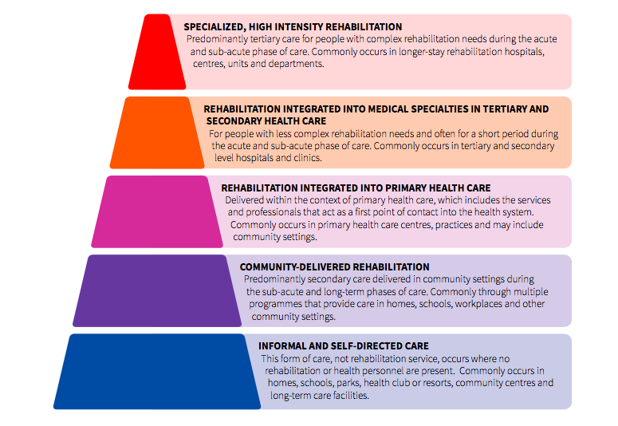
Rehabilitation should be available at all levels of healthcare, from specialist referral centers through to primary and community settings. Rehabilitation interventions are delivered in health facilities as well as in the community, such as in homes, schools and workplaces. Rehabilitation is a highly person-centered form of health care, it is goal orientated (i.e. very individually tailored), time bound and an active rather than passive process. Rehabilitation is most commonly delivered through a multi-disciplinary team including therapy personnel, namely physiotherapists, occupational therapists, speech and language therapists, prosthetists and orthotists, psychologists and through specialist rehabilitation medicine doctors and nurses, it can also be delivered through appropriately trained community-based rehabilitation personnel and other health personnel. In this report, as with other WHO documents, the word rehabilitation also includes habilitation.
Rehabilitation is for all the population; this includes people with disabilities as defined by the United Nations Convention on the Rights of Persons with Disabilities (UNCRPD), as well as many others. People with short-term health conditions also benefit from rehabilitation and it commonly contributes to the prevention of impairments associated with disability. Rehabilitation regularly optimizes surgical outcomes, decreases the length of hospital stay, prevents complications, decreases re-admissions and facilitates a return to optimal functioning. Many people with disabilities also benefit from rehabilitation, and in addition to rehabilitation many people with disabilities require other programs, such as those that support their social inclusion, their participation in education, their attainment of a livelihood or their access to justice. Programs that include people with disabilities and whose primary aims are education, training, employment or social inclusion should be delivered through non-health ministries and align to the mandate of that ministry.

APPENDIX B – Rehabilitation in Health Systems – A Guide for Action
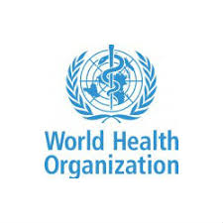

REHABILITATION IN HEALTH SYSTEMS – A GUIDE FOR ACTION
Overview
“Rehabilitation in Health Systems – A Guide for Action” (the Guide) assists governments to strengthen the health system to provide rehabilitation.

This initiative is a result of the February 2017 “Rehab 2030: A call for Action” meeting in Geneva.

The Guide is a 4-step process that is estimated to take about one year to complete (each country is different). WHO has developed standard data collection tools; these were first used in 2018.

In general, the process starts when the Ministry of Health expresses interest in the process and/or requests technical support from WHO for this activity.

The assessment is based around the six building blocks for health systems strengthening. Application to rehabilitation is outlined for each building block.

The Four-Phase Process
Objective | WHO Guidance | Tools | Activity Timeline
1. Assess the situation | Systematic Assessment of Rehabilitation Situation (STARS) | Template for Rehabilitation Information Collection (TRIC): 8 domains, 97 questions; MoH self-assessment  Rehabilitation Maturity Model (RMM): 7 domains, 50 questions; consultant-supported scoring | TRIC: January 2020  In-country assessment February 10-28, 2020  Zero-draft report: March 13, 2020  First draft: April 29, 2020
2. Develop a rehabilitation strategic plan. | Guidance for Rehabilitation Strategic Planning (GRASP) | Results from STARS report contributes to development of strategic plan. | Anticipated dates:  April 27-May 8, 2020
3. Establish monitoring evaluation and review process | Framework for Rehabilitation Monitoring and Evaluation (FRAME) | FRAME guidance assists in establishing a monitoring framework including the selection of indicators. | To happen simultaneously with Strategic Plan
4. Implement the strategic plan | Action on Rehabilitation (ACTOR) | Planning, action, and evaluation cycle | After Strategic Plan and Monitoring Framework are in place

The WHO health system building blocks are an important framework reflected within the Guide. Across the six building blocks are components that reflect rehabilitation. The table below illustrates the health system building blocks and corresponding rehabilitation components. The assessment and measurement of these rehabilitation components is a subject of the tools in the Guide.
Health system building blocks and rehabilitation
The Six Building Blocks of the Health System | Components Reflecting Rehabilitation
- Leadership and governance | - Laws, policies, plans and strategies that address rehabilitation.  - Governance structures, regulatory mechanisms and accountability processes that address rehabilitation.  - Planning, collaboration and coordination processes for rehabilitation.
- Financing | - Health expenditure for rehabilitation.  - Health financing and payment structures inclusive of rehabilitation.
- Health workforce | - Health workforce that delivers rehabilitation interventions - primarily rehabilitation medicine, rehabilitation allied health / therapy personnel and rehabilitation nursing.
- Service delivery | - Health services that deliver rehabilitation interventions, including rehabilitation delivered in rehabilitation wards, units and centers, in hospital settings and rehabilitation delivered in primary care facilities and other community settings. The availability and quality of rehabilitation are considered.
- Medicines and technology | - Medicines and technology commonly utilized by people accessing rehabilitation, primarily assistive products.
- Health information systems | - Data relevant and inclusive of rehabilitation in the health information systems. For example, population functioning data, rehabilitation availability and utilization data, rehabilitation outcomes data.

APPENDIX C – Map of Georgia
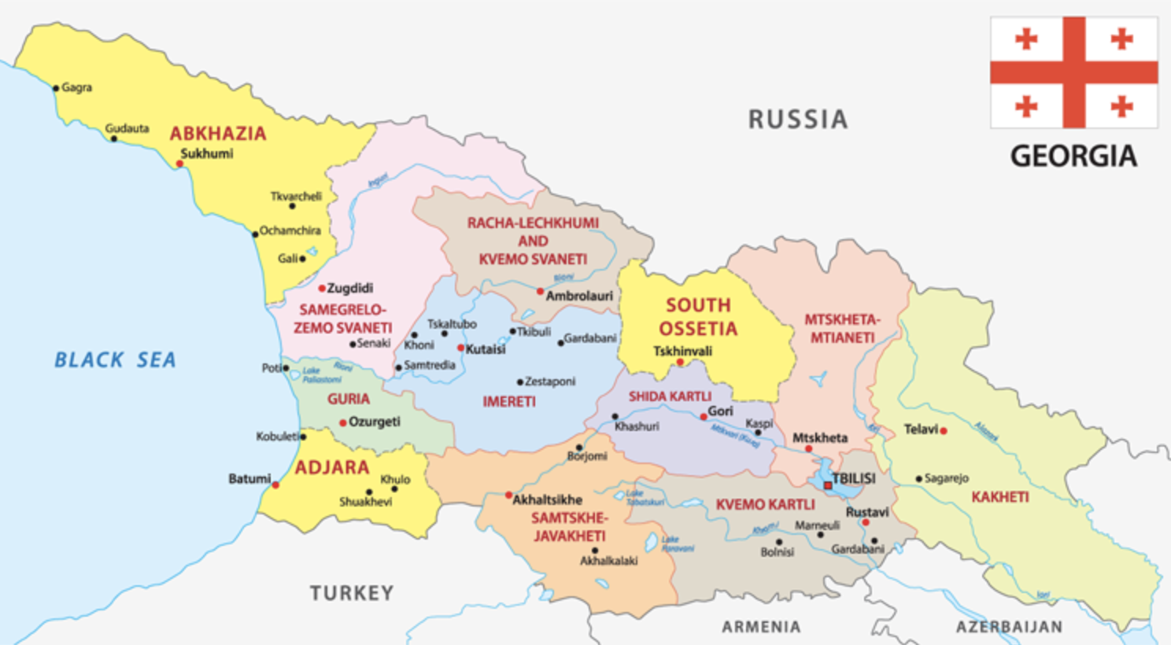

APPENDIX D – In-Country Schedule
Systematic Assessment of Rehabilitation Situation in Georgia
Date | Activity | Location
Sat 08 Feb 2020 | Ms. Eitel Arrival in Georgia | Tbilisi
Monday  10 February 2020 | Mr. Mishra Arrival in Georgia | Tbilisi
Monday  10 February 2020 | In-brief with WHO | Tbilisi
Monday  10 February 2020 | 1. MoLHSA Focal Points | Tbilisi
Monday  10 February 2020 | 2. MoLHSA First Deputy Minister | Tbilisi
Monday  10 February 2020 | 3. Topic Specific: Governance /Emergency | Tbilisi
Tuesday  11 February 2020 | 4. Topic Specific: Finance | Tbilisi
Tuesday  11 February 2020 | 5. MoLHSA Consultant for National Strategic Plan | Tbilisi
Tuesday  11 February 2020 | 6. Topic Specific: Information Systems | Tbilisi
Wednesday  12 February 2020 | 7. Topic Specific: Human Resources (Training and Workforce) | Tbilisi
Wednesday  12 February 2020 | 8. Topic Specific: Service Delivery and Assistive Technology | Tbilisi
13 February 2020 | 9. Strengths-Weaknesses-Opportunities-Threats (SWOT) | Tbilisi
Friday  14 February 2020 | 10. Focus Group – Service Providers (centers) | Tbilisi
Friday  14 February 2020 | 11. Focus Group – Service Providers (individuals) | Tbilisi
Friday  14 February 2020 | 12. Focus Group – Service Users | Tbilisi
Sat 15 Feb 2020 | Mishra Departure from Georgia | Tbilisi
Monday  17 February 2020 | 13. Aversi Rehabilitation Center | Tbilisi
Monday  17 February 2020 | 14. Aversi Clinic – Otorinolaringologist, Audiologist | Tbilisi
Monday  17 February 2020 | 15. Tbilisi State Medical University (Physical Therapy Training) | Tbilisi
Monday  17 February 2020 | 16. Tatishvili Center/Health Palace | Tbilisi
Tuesday  18 February 2020 | 17. Polyclinic #14 –Disability Determination Commission | Tbilisi
Tuesday  18 February 2020 | 18. Polyclinic #14 – Rehabilitation Service | Tbilisi
Tuesday  18 February 2020 | 19. Neurodevelopment Center | Tbilisi
Tuesday  18 February 2020 | 20. Georgian Foundation for Prosthetic Orthopedic Rehabilitation | Tbilisi
Wednesday  19 February 2020 | 21. MAC Georgia | Tbilisi
Wednesday  19 February 2020 | 22. Ilia State University (Speech Therapy Training) | Tbilisi
Wednesday  19 February 2020 | 23. Center for Independent Living | Tbilisi
Thursday  20 February 2020 | 24. UNICEF | Tbilisi
Thursday  20 February 2020 | 25. Rehabilitation Center for Persons Having Limited Ability Ltd. | Tbilisi
Thursday  20 February 2020 | 26. Ken Walker University Clinic for Medical Rehabilitation LLC | Tbilisi
Friday  21 February 2020 | 27. Aversi Rehabilitation staff | Tbilisi
Friday  21 February 2020 | 28. PFID / Emory University Rehabilitation Project | Tbilisi
Friday  21 February 2020 | 29. PSP New Hospitals – Neuro-rehabilitation Department | Tbilisi
Sunday 23 Feb 2020 | Travel to Adjara – overnight Batumi | Batumi
Monday  24 February 2020 | 30. Adjara Ministry of Health and Social Affairs | Batumi
Monday  24 February 2020 | 31. Ken Walker Clinic Batumi | Batumi
Monday  24 February 2020 | 32. Chakvi Neuro-rehabilitation Center (Evex) | Batumi
Monday  24 February 2020 | 33. Batumi Shota Rustaveli State University | Batumi
Monday  24 February 2020 | 34. 1 Polyclinic Batumi – UNICEF Pilot Project Site / Rehabilitation Service | Batumi
Tuesday  25 February 2020 | Travel to Tbilisi | Tbilisi
Tuesday  25 February 2020 | 35. Caritas (office and rehabilitation unit) | Tbilisi
Tuesday  25 February 2020 | 36. USAID | Tbilisi
Tuesday  25 February 2020 | 37. Professional Standards Working Group | Tbilisi
Wednesday  26 February 2020 | 38. Akhaltsikhe Municipality | Akhaltsikhe
Wednesday  26 February 2020 | 39. Lung Disease Rehabilitation Center | Abastumani
Thursday  27 February 2020 | 40. Ministry of Education and Sport – Higher Education | Tbilisi
Thursday  27 February 2020 | 41. Tserovani Military Rehabilitation Center (MOD) |  | Tbilisi
Friday 28 Feb 2020 | Debriefing | Tbilisi
Sat 29 February 2020 | Eitel Departure from Georgia | Tbilisi

APPENDIX E – 2014 Census Information on Functioning

Description of  Function | Total Population  (3,713,804) | Description of Limitation |  |  |  | Total  Responses
Description of  Function | Total Population  (3,713,804) | No difficulty | Some difficulty | A lot of difficulty | Can’t do it at all | Total  Responses
Seeing |  | 3,097,544 | 468,710 | 98,480 | 9,158 | 3,673,892
Percent of total population |  | 83% | 12.6% | 2.65% | .25% | 98.9%
Hearing |  | 3,434,688 | 191,501 | 41,621 | 6,082 | 3,673,892
Percent of total population |  | 93% | 5.2% | 1.1% | .16% | 98.9%
Walking or climbing steps |  | 3,452,894 | 144,322 | 60,681 | 15,995 | 3,673,892
Percent of total population |  | 93% | 3.9% | 1.6% | .43% | 98.9%
Remembering/concentrating |  | 3,573,168 | 72,906 | 21,987 | 5,831 | 3,673,892
Percent of total population |  | 96% | 1.96% | .59% | .16% | 98.9%
Communicating |  | 3,607,943 | 42,919 | 16,246 | 6,784 | 3,673,892
Percent of total population |  | 97% | 1.15% | .44% | .18% | 98.9%
Self-Care |  | 3,575,440 | 57,275 | 25,951 | 15,226 | 3,673,892
Percent of total population |  | 96% | 1.5% | .698% | .41% | 98.9%
TOTAL |  | N/A | 977,633 | 264,966 | 59,076 | 1,301,675
Percent of total population |  | N/A | 26.3% | 7.13% | 1.59% | 35%
Refusal |  |  |  |  |  | 7,262
Percent of total population |  |  |  |  |  | .195%
Not stated |  |  |  |  |  | 32,650
Percent of total population |  |  |  |  |  | .879%

APPENDIX F – Rehabilitation SWOT - Raw Data
GOVERNANCE
Strength
- Existing legal framework for PWD; Convention and disability law; International convention CPRD ratified
- Draft law on the rights of the disabled; Ratification of convention of rights
- Updated structure of MOLHSA; New Policy Department with Health and Social policies function
- Rehabilitation service registration requirement (for children) are clear and sufficient
- Country is piloting functional assessment
- There are some policies and resources connected to AT
- Government readiness to collaborate in order to have change
- Government is open to collaborate with professional associations, and service providers and donors
- There is an existing rehabilitation program, but targets particular groups (pediatric 0-18 years)
- Doctor of rehabilitation is regulated – there is license but is open ended – no requirement for CPD.
- Planned assessment (HRAP?) – adult rehabilitation needs assessment

Weakness
- Convention protocols not ratified
- Lack of evidence (no statistics on number and location of workforce from govt).
- Non-effective budget management; inefficient spending of budget; low budget
- No insurance coverage (private, UHI)
- Regulation is few – which is connected to the disabled people (disability status)
- No law connected to rehabilitation outside law on persons with disabilities
- No strategic plan connected to rehabilitation; no consensus on strategic vision; no existence of strategy
- No guidelines and standards for rehabilitation; absence of national standards and regulation
- Rehabilitation professionals are not regulated
- Restructuring if MOLHSA
- No systematic approach – human relationships dictate decisions.
- Lack of human resources at policy development level.
- Rehabilitation exists outside of health system – not yet integrated in health – mainly social department program.
- No systematic approach for referrals
- No coordination system (internal/external) within and between ministries, NGOs and municipal/central levels
- Permanent licensing for PT based on university program (no licensing for other professionals)
- No licensing requirement for clinics

Opportunities
- Grants, projects and donor organization interest; donor organization interest and support; donor readiness
- Rehabilitation 2030 and WHO support; WHO technical support & international organization
- High-up on the global agenda;
- International partnership; international experience
- Increasing demand for rehabilitation
- Business interest; interest from local investors; growing private sector interest in rehabilitation clinics

Threats
- Geo-political situation; territory conflicts; looming security threats (Russia)
- Systematic changes of government; frequent changes in the country’s leadership
- Donor support withdrawing/weakening
- Emigration of workforce and patients
- Poverty – increases disability and also influences the access to services
- Budget deficit of the country
- Public stereotypes – rehabilitation vs. disability
- Window of opportunity is now – can’t miss this chance as there is attention to rehab now.
- Deficit of services; existing services cant be accessed by users

INFORMATION SYSTEMS
Strengths
- There are reports from the government every year about services that they provide
- Annual report by MOH including rehabilitation part
- There is information about programs and services on the MOH Website
- Information on available rehabilitation programs on SSA Website (which is accessible)
- There is data of disabled people who are getting financial support
- Legal framework exists in line with the CRPD on information accessibility and transparency
- Government has a list of service providers; information about service providers
- Guidelines electronic format exists
- Census includes basic questions about mobility (GeoStat)
- HMIS exists

Weaknesses
- No user satisfaction data is collected on available programs
- No research conducted (2); no research on rehabilitation; research relevant to rehab policy and programs
- Incomplete databases and statistics
- No population data functioning (2); non-existence of completed pop functioning data
- HMIS not collecting rehab data
- Lack of analyses of provided rehabilitation services
- Rehab availability and use data and out come data
- EHR (electronic health records?) not include rehabilitation
- Development of HER in our country
- No possibility to exchange information between stakeholders; no links between services
- No regional statistics; no information about services in regions; no info on beneficiary needs in the regionas
- Lack of information for beneficiaries on what they are entitled to (P&O, AT)
- Low level of English among practitioners and no access to international research studies etc
- Statistics does not exist on the needs of rehabilitation (# of people, necessary intensity) – except NCDC collects some data on rehabilitation but we don’t know the methodology.

Opportunities
- Improve health information systems to include municipalities about available benefits
- Research institutions; to develop research projects
- There are WHO statistics connected to disability and services needs
- To develop E systems
- Internet gives opportunity to spread information in regions
- International expertise on collecting data, methodology, etc
- Donor supported activities for spreading information (fliers printed, video clips)
- Descriptions and explanation of rehabilitation programs
- Young professionals/associations members realize slowly the need for research through international exposure
- National statistics / conduct statistical researches
- Evidence based practice information

Threats
- Limited service access due to information vacuum
- Lack of investment from donor organization
- Lack of awareness of need for research/evidence-based treatment among policy makers and rehab specialists
- Information vacuum due to lack of information system
- Information technology limited access creates information deficit about services
- High mountainous regions, ethnic minorities lack access to IT (language problems)
- Lack of opportunity to be involved into international researches
- Losing trust from donors

HUMAN RESOURCES
Strengths
- There are a variety of specialists; qualified specialists (BA, MA, PhD); certified specialists
- Periodic international exchange and exposure
- Existence of short-term and life long education
- There are professional competencies
- Local expertise and qualified trainers
- TSMU received international accreditation
- Professional associations
- University education for PT, OT, ST; accredited curriculum OT, PT, SL; educational; programs (PT, ST, OT, nurse)
- More PT, ST, OT are representatives of new generation (more motivated, smart)
- Post-graduation (for doctors)
- Increasing number of qualified programs producing professional staff
- TOT and other trainings
- Diplomas are valid in European countries

Weaknesses
- No rehab nurses; not qualified nurses on rehabilitation
- Lack of almost all rehab professionals
- No retraining system
- TSMU needs further support
- Weak and segregated professional associations
- Lack of interest/demand – not getting the strongest students
- Low awareness about PT/OT/ST and P&O professions
- PT/OT/ST not popular compared to other programs; popularity lacks
- PT/OT/ST/Nurses are not equal members of the rehab team
- Lack of continuous professional development programs; Lack of lifelong education programs/system
- Tbilisi-focused—professionals don’t go beyond capitol; little to no cadre in rural areas
- Too few international linkages/professional development
- No regional academic programs
- No attention to community-based rehabilitation workforce
- Not regulated - many unqualified persons in the system
- Low income; low salaries
- Teamwork difficulties (patient and rehab team)
- Formal education for P&O does not exist – trainings are short term and lack in-service format
- Profession does not cover the continuum of care for all patient groups
- Inadequate clinical opportunity in training (low level of clinical reasoning developed)
- Lack of qualified professors to provide the new curriculum
- No certification or regulation for OT/PT/ST; some professions are not regulated
- Insufficient number of professionals – especially in the regions; lack or no specialists in regions
- Lack of involvement of professional associations in rehabilitation
- There is not the same language used between specialists
- Self-funded education system
- More of medical model vision in specialists
- Confusion in rehab professional titles/standards/job descriptions
- Lack of education programs for specialists that are needed
- Lack of professional resources and literature in Georgian

Opportunities
- Demand for professionals
- Donor-supported professional development programs; more focus on the profession from donors
- International best practices and opportunity to collaborate; international supervision
- Opportunity to establish modern system with a new vision
- Involvement of experts/specialists from developed countries
- International training programs
- Donor support
- Improving economy and growing private wealth
- Some recognition of the need for properly trained professionals
- Lifelong education practices in foreign countries
- Availability of professional standards and competencies
- Make PT/OT/ST/nurse specialists more popular
- Resource of professional associations (more cooperation)
- Increase and development of high-quality educational programs

Threats
- Low service quality due to the current situation
- Migration (emigration?) of professionals; emigration of workforce; emigration of professionals
- Out migration of specialists
- Lack of attention from central government
- Growing poverty
- Migration of clients/patients
- Mentality
- Concentration of workforce in one place (Tbilisi)
- Discrimination
- Frame(?) – trainee(?) – brain(?) leak
- Economic downturn
- Failure to establish competitive wages
- Diminishing returns on established academic programs
- Replacement of local specialists by others

FINANCE
Strengths
- Strong state control system for financial expenditure (voucher system)
- Some municipalities fund rehabilitation for disabled children and adults; municipality finds autism program
- Existing available budget (Adjara and Central level) for vulnerable and disabled
- Abkazia government in exile also supports programs but for refugees from this region
- Existing state financing for disabled children; pediatric rehabilitation is funded
- Existing state financing for AT for children and adults; state programs for disabled & children for AT, rehab etc
- Aids and adaptations is funded by government for children and adults
- MOH funds some rehab programs for adults like balneology
- Donor financial support for creating system and for professional development
- Increased flexibility of moving funds around between programs (eg. ECD to home care); rehab funds more flexible
- Govt has 4.4M GEL rehabilitation budget
- MOH finances adult rehabilitation in foreign countries (if the needed program is not in the country)
- Transparency of state budget (information is accessible)
- Development of rehabilitation strategic plan

Weakness
- No fixed salaries for professionals; low salaries of specialists; low finances for professional salaries/services
- Insufficient budget; limited budget; insufficient funding and long waiting list for rehabilitation
- No funds for specialists’ quality development
- Children’s rehab in foreign countries is not funded by MOH
- Funding not flexible – predetermined sessions/beneficiaries; budget not flexible – long waiting lists
- Budget ceiling not defined by MOLHSA (but by MoF); changes in budget by financial ministry is not effective
- Bureaucracy of spending (timing)
- No priority for rehabilitation funding
- Annual budget is vulnerable, not stable
- Rehabilitation budget is not evidence or needs based
- Insufficient budget, not flexible, not evidence-based, not inclusive, not prioritized or adapted to beneficiary needs
- Inefficient spending of budget (social pension) within existing voucher system in children’s rehabilitation
- Universal health insurance/private insurance companies not covering the service (nor high risk groups – athletes)
- Ineffective financial management – no funds for prevention, early intervention, awareness
- Increased funds means increasing the number of beneficiaries – not the quality of services.

Opportunities
- International experience in health financing and payment structure (best practices); international partnership
- International standards for cost-effective spending can be adapted to Georgia
- Medical tourism (lots of resorts can attract tourists)
- Increasing budget in line with international standards
- Involving business sectors in/with funding; business interest and incentives and private investment (PPP)
- Bottom-up budget planning (participatory)
- Decentralization of budget spending (municipalities)
- Donor support
- Strategic rethinking for funding mechanism

Threats
- Growing poverty, inflation, economic instability (devaluation/inflation); currency exchange
- Low employment in general
- Conflicts, force major (war)
- No readiness to migration; going for service abroad/monetary resources going out of the country
- Less or no interest from donor organizations
- Monopoly; decreased number of quality service providers
- Decreased quality of service due to insufficient funding

ASSISTIVE TECHNOLOGY
Strengths
- MOH provides some meds and adaptations
- Current govt. programs finance 11 ATs (in addition, Adjara govt finances medical beds and transfer lifts)
- Apart from 11 ATs, cochlear implant is also funded by government programs
- Wheelchairs and P&O are locally produced which ensures continuous supply (+ power wheelchair is financed)
- Manual wheelchairs are provided every two years; orthoses are available every year
- Existing competence in Georgia of service provider professionals and some for AT
- Orthopedic AT market is more or less developed
- Some basic medicines are covered by UHC
- Growing number of wheelchair service personnel required by international standards (ie WHO)
- Definition of ATs & their group & program by MOLHSA is available

Weaknesses
- Inefficient system for delivery of services
- No quality control for AT
- No nationally approved list of ATs needed for Georgia; no adapted AT essential list for govt. funds
- Lack of diversity of AT and appropriately trained personnel to provide related services
- Lack of diversity of assistive technologies and adaptations
- Service levels not differentiated according to prices
- Growing portfolio of AT and trained personnel (W/C)
- Access to state funds for AT is very complicated, long and bureaucratic –inefficient
- Medicines made OTC (over the counter?)
- Assistive product provision process not following WHO guidelines (8-step process): eg. fitting, user trng, follow-up
- No financial support for fitting and user training or provided aids and adaptations
- Lack of competition of AT producers
- People under-benefitting from AT due to missing link between AT and medical rehab services (limited awareness)
- Lack of quality services (no seating support parts funded for manual wheelchairs)
- There are available medications for rehab but has high price and not financed by MOH
- Lack of possibility to get high-tech aids and adaptations and specialists to teach how to use them
- Quality of manufactured ATs depends on state funding (ie. its limited)
- Government policies is as cheap as possible
- Some meds are provided by MOH if person has disability status
- No training for users/carers in AT maintenance and use
- Low quality of medicines
- Assistive technologies are not accessible because of high price and in some fields, poor choice.
- Difficulties introducing new technologies on the local market due to high cost & low qualification of HR
- Provision of AT is tied to disability status (eg. power wheelchair is provided only to disabled)
- Limited types of assistive products (11 out of 50)
- Out of 50 AT identified by WHO, only 11 are financed; state program funds AT – not full list should be 50.
- Inflexible procurement system of MOH (tenders).

Opportunities
- Donors distribute wheelchairs
- Public-private partnership for production/assembly of AT
- Availability of some new technologies and improved service if funding available (war veterans, military)
- WHO regulated documents and standards connected to the aids and adaptations (e.g wheelchairs)
- Availability of different organizations providing aids and adaptations
- International projects
- Patient education
- Increase awareness about AT
- Increased diversity and availability of AT
- Existence of various AT models
- Donor support to increase availability of innovative ATs
- Donor support for trainings, set-up workshops, and standards
- PWD employment increases social life (production of AT)
- Minimal lists of aids and adaptive provided by WHO
- International frameworks on AT/ service delivery that can be adjusted to Georgian context.

Threats
- No development of AT fields (P&O)
- Increase disability decrease functionality
- Self-treatment
- Lack of repair for imported AT products
- Emigration of qualified personnel (future of AT production)
- Decreased quality of AT
- Further limitation of available ATs and quality
- High chance of missing private initiatives that are providing aids and adaptations
- Having no minimum standards increases low quality meds and adaptations
- Vulnerability of nowadays system

SERVICES
Strengths
- Some rehab clinics and centers already exist; availability of services
- Existing experience – resort therapy
- Adult rehab service in Batumi
- Existing rehab program for children – early intervention programs
- Many centers available for children
- State support for service providers (financial and programmatic)
- Readiness to improve rehab program, get new and qualified professionals and programs
- Center-based rehabilitation in some cities for children
- State program or municipal program covers some services
- Professional association in rehabilitation

Weakness
- Quality of service delivery
- Physical accessibility to service structures
- No rehab services in hospitals and community settings; no rehab in hospitals or PHC level
- Rehabilitation is not integrated into primary health care
- Few rehab centers – with most in Tbilisi; rehabilitation not available in all municipalities
- Physicians remain gate-keepers of rehabilitation
- No regulation of rehab centers
- Few professional staff and they are limited to Tbilisi
- No monitoring of quality- no results-based care
- No homecare for ATs / P&O (no information about beneficiaries available to service providers)
- Limited services funded by state only for children and disabled
- Lack of communication in service delivery
- Money is earned by keeping patients in bed… financial incentives vs. disincentives for rehabilitation
- No geriatric rehabilitation and no prevention services (eg. fall prevention programs)
- P&O manufacturing only available in Tbilisi
- Service provision is centralized (only available in cities) not in regions or communities
- No adult rehabilitation services; no adult rehab program in MOH
- Sill focused on modalities and passive treatment – not functional assessment
- No support groups of any kind
- Lack or no rehab for children’s programs in the regions
- Rehab not provided along the full continuum of care (nor in space or time?)
- No first aid rehab program
- Little concept of rehab within a hospital setting (in-patient rehab doesn’t really exist)
- Standards for many of rehab services not exist
- Lack of services – especially in the regions – no rehab at community level
- Rehab often delivered by unqualified persons
- Limited access for ethnic minorities – language barriers (same for Deaf/hard of hearing)
- No or lack of team approach in rehab services (NDC has it)
- Rehab services are all over the boad. No regulation and no accepted understanding of what it should look like.
- No or lack of group therapy in rehab system

Opportunities
- Good, natural conditions for balneology (but don’t use them)
- Develop telemedicine services
- One-stop service provision – provide full range of services in one location
- Strengthening of regional education in rehab professions
- Development of state strategy
- Political will to develop services
- International partnership
- Collaboration with international associations
- Donor support
- Possibility of international education
- Arrival of rehab center/hospital - opportunity to establish more complete continuum of care
- Public private partnership
- Improve hospital infrastructure to provide rehab
- Decentralization – improved communication between state funds, service providers and beneficiaries

Threats
- Increased number of disabled due to limited service availability
- Further deterioration of quality of service provision
- No existing hospital rehabilitation services
- Brain drain
- Lack of finance for new services
- Not having healthy competition, rehab is at risk of low quality service
- Because of lack of clients / patients using services, it might be diminished

APPENDIX G – Preliminary Findings – Debriefing Document

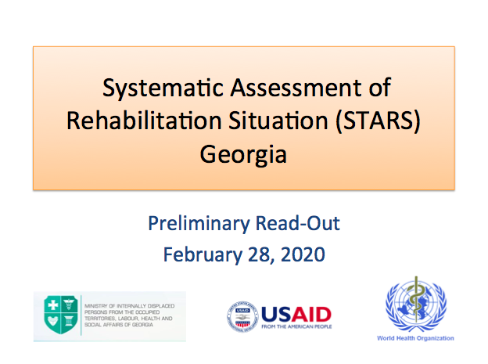
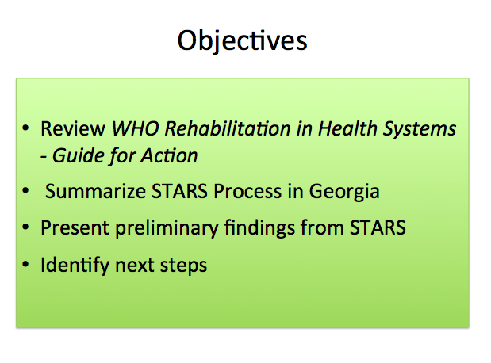
Slide 1. Slide 2.

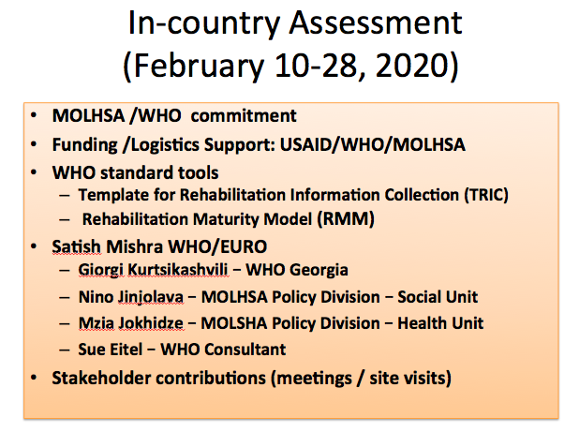
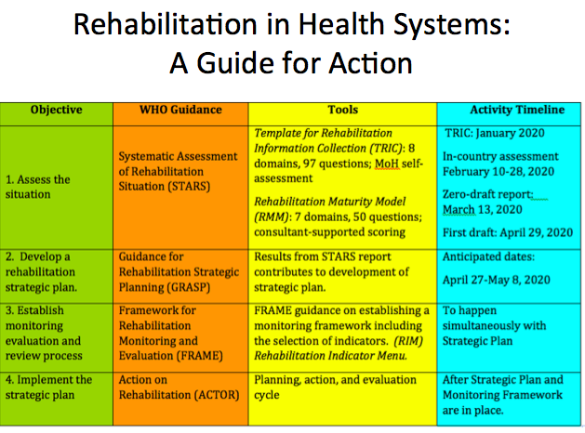
Slide 3. Slide 4.

Slide 5. Slide 6.
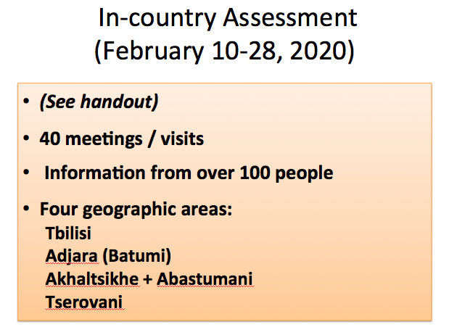
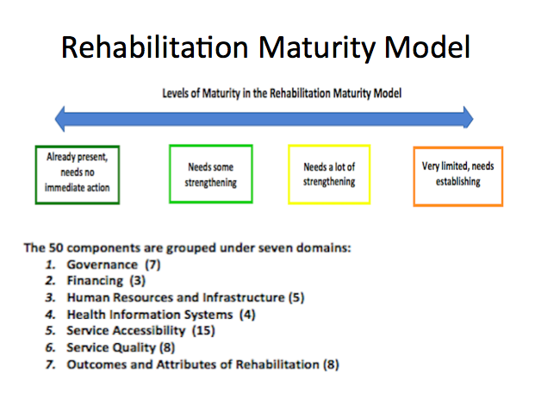

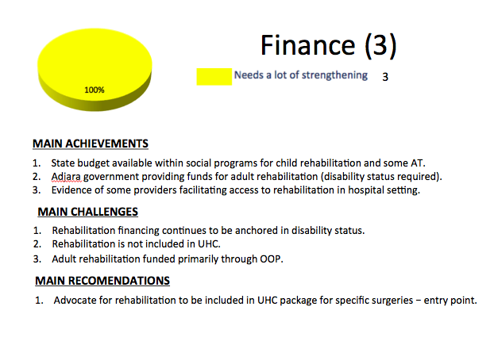
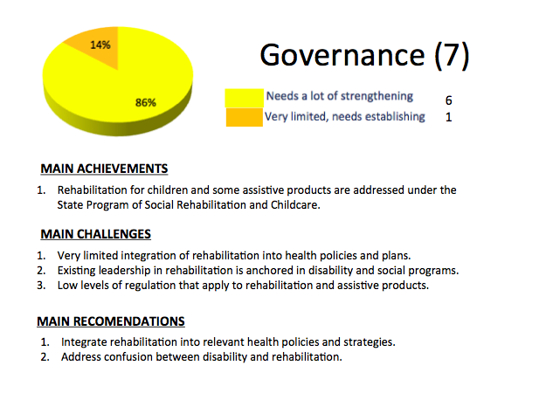
Slide 7. Slide 8.

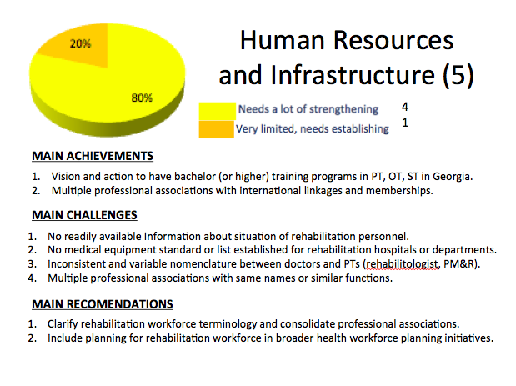
Slide 9. Slide 10.
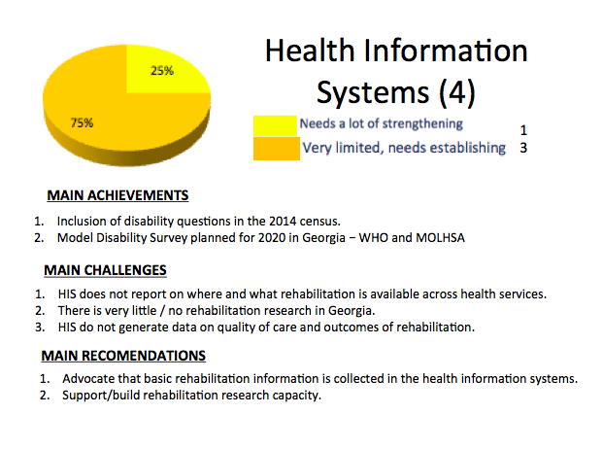

Slide 11. Slide 12.
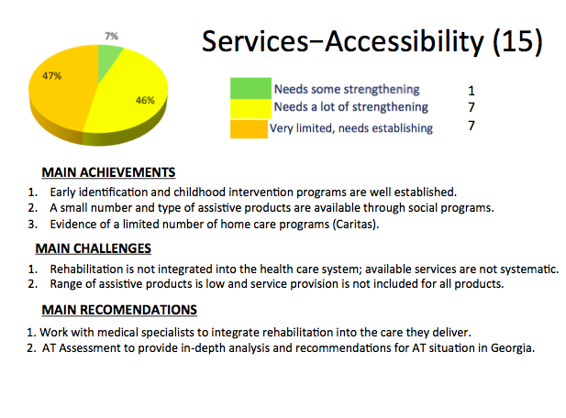
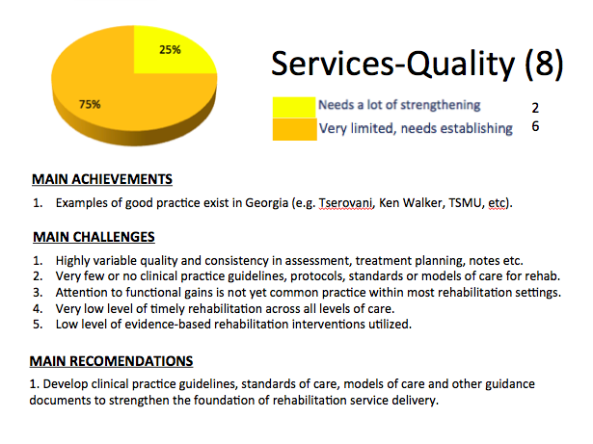


Slide 13. Slide 14.
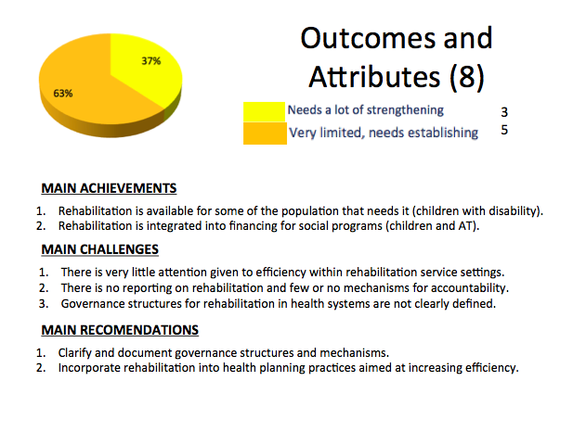

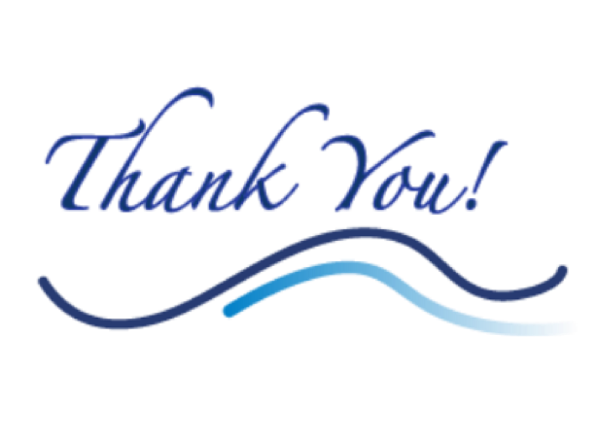
Slide 15. Slide 16.
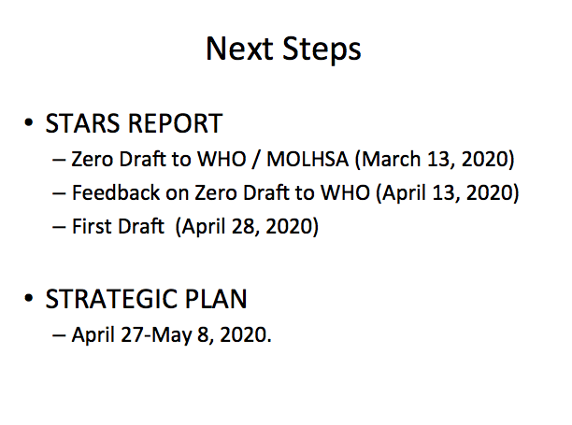

APPENDIX H – Key Contacts from In-Country Assessment

NO | NAME | ORGANIZATION | EMAIL | PHONE
1. | MoLHSA FOCAL POINT MEETING (FEB 10, 2020)
1 | Nino Jinjolava | Chief Specialist, Social Protection Policy Unit | njinjolava@moh.gov.ge | +995 577 49 35 58
2 | Mzia Jokhidze | Chief Specialist, Health Policy Unit | mjokhidze@moh.gov.ge | +995 577 28 28 87
3 | Giorgi Kurtsikashvili | WHO Georgia, Rehabilitation Focal Point | kurtsikashvilig@who.int
4 | Satish Mishra | WHO Euro Region, Disability and Rehabilitation Office | mishras@who.int
5 | Sue Eitel | Consultant | eitelglobal@gmail.com
6 | Maya Mateshvili | Interpreter | mateshvilim@gmail.com
2. | MoLHSA DEPUTY FIRST MINISTER (FEB 10, 2020)
1 | Dr. Tamar Gabunia | First Deputy Minister MoLHSA
2 | Dr. Silviu Domente | WHO Representative and Head of WHO Country Office | domentes@who.int | +995 599 47 54 85
* | Assessment Team: Nino Jinjolava, Mzia Jokhidze, Giorgi Kurtsikashvili, Satish Mishra, Sue Eitel/Maya Mateshvili
3. | TOPIC SPECIFIC MEETING: GOVERNANCE AND EMERGENCY (FEB 10, 2020)
1 | Amiran Gogitidze | LEPL Emergency Situations Coordinatn. & Urgent Assistance Center  Head of Medical and Call Management Department | Agogitidze@moh.gov.ge | +995 595 07 37 97
2 | Ketevan Kiladze | Chief Specialist, Service Dept of Medical Pharm Regulation Agency | kkiladze@moh.gov.ge
3 | Khatuna Zaldastanishvili | Head of Department of Professional Regulation, MoLHSA | khzaldastani@gmail.com
4 | Medea Kakachia | USAID Project Management Specialist | mkakachia@usaid.gov | +995 599 58 93 06
5 | Sabina Ciccione | Program Director, Physical Rehabilitation Project in Georgia | Sciccone.rehab@gmail.com | +995 598 73 00 51
* | Assessment Team: Nino Jinjolava, Mzia Jokhidze, Giorgi Kurtsikashvili, Satish Mishra, Sue Eitel/Maya Mateshvili
4. | TOPIC SPECIFIC MEETING: FINANCE (FEB 11, 2020)
1 | Darejan Iakobishvili | Chief Specialist of Financial Economic Department MoLHSA | diakobishvili@moh.gov.ge | +995 599 97 26 27
2 | Nana Cherkezishvili |  | Ncherkez44@yahoo.com | +995 595 09 28 96
3 | Irakli Natroshvili | Director, Ken Walker University Clinic for Medical Rehab LLC | irakli.natroshvili@kwclinic.ge | +995 599 48 12 21
4 | Lela Tsotsoria | Chief Specialist Health Care Department | ltsotsoria@moh.gov.ge | +995 577 94 94 91
5 | Ketevan Goginashvili | Chief Specialist Health Care Policy Division | kgoginashvili@moh.gov.ge
* | Assessment Team: Nino Jinjolava, Mzia Jokhidze, Giorgi Kurtsikashvili, Satish Mishra, Sue Eitel/Maya Mateshvili
5. | MoLHSA CONSULTANT FOR NATIONAL STRATEGIC PLAN (FEB 11, 2020)
1 | Dr. Lagos Kovacs | Senior Expert in Health Policy and Strategic Planning | info@lajoskovacs.com | +995 557 33 39 11
* | Assessment Team: Giorgi Kurtsikashvili, Satish Mishra, Sue Eitel
6. | TOPIC SPECIFIC MEETING: INFORMATION SYSTEMS (FEB 11, 2020)
1 | Alexander Turdziladze | NCDC, Deputy Director General | a.turdziladze@ncdc.ge
2 | Lia Charekishvili | GeoStat, Head of Social Infrastructure Statistics Division | lcharekishvili@geostat.ge
3 | Mariana Jalagoinia | GeoStat, Population Census and Demographic Statistics Dept. | mjalaghonia@geostat.ge
* | Assessment Team: Nino Jinjolava, Mzia Jokhidze, Giorgi Kurtsikashvili, Satish Mishra, Sue Eitel/Maya Mateshvili

NO | NAME | ORGANIZATION | EMAIL | PHONE
7. | TOPIC SPECIFIC MEETING: HUMAN RESOURCES - TRAINING AND WORKFORCE (FEB 12, 2020)
1 | Tamila (Tea) Eristavi | Social Rehabilitation Center for Persons with Limited Ability | Teoeristavi@yahoo.com | +995 599 18 13 36
2 | Neli Kakulia | Georgian Association of Physiotherapists | Nelly_kakulia@yhaoo.com | +995 599 55 40 06
3 | Medea Kakachia | USAID Project management specialist | mkachia@usaid.gov | +995 599 58 93 06
4 | Rusudan Bochorishvili | GCECI | rusudanbochorishvili@gmail.com | +995 599 65 55 08
5 | Nino Tsintsadze | Ilia State University | ninotsintsadze@iliauni.edu.ge | +995 593 34 45 32
6 | Nino Rukhadze | Ivane Javakhishvili State University (TSU) occupational therapy | nino.rukhadze.m@tsu.ge | +995 577 44 87 19
7 | Rusudan Lortkipanidze | Georgian Occupations Therapists’ Association | lortkipanidzer@gmail.com | +995 593 00 02 88
8 | Mamuka Gogorishvili | GEFPOR | mamuka@gefpor.ge | +995 577 79 19 94
9 | Marika Kalmakhelidze | GEFPOR | marika@gefpor.ge | +995 577 42 62 15
10 | Eliso Murvanidze | G.P.T.A | murvanidzeeliso@yahoo.com | +995 599 23 22 37
11 | Khatuna Zaldastanishvili | MoLHSA, Head of Department.of Professional Regulation | khzaldastani@gmail.com | +995 577 53 53 29
12 | Ketevan Kiladze | MoLSHA, Agency of Medical Regulation, Prof. Reg Department | kkiladze@moh.gov.ge | +995 599 43 30 43
13 | Lela Maskhulia | TSMU, Dean of Physical Medicine and Rehabilitation Faculty | L.maskhulia@tsmu.edu | +995 577 75 34 23
14 | Archil Undilashvili | Emory University Atlanta, GA, USA | aundila@emory.edu | +995 599 54 03 01
15 | Sabina Ciccone | PFIO, Project Director | sciccone.rehab@gmail.com | +995 598 73 00 51
* | Assessment Team: Nino Jinjolava, Mzia Jokhidze, Giorgi Kurtsikashvili, Satish Mishra, Sue Eitel/Maya Mateshvili
8. | TOPIC SPECIFIC MEETING: SERVICE DELIVERY AND ASSISTIVE TECHNOLOGY (FEB 12, 2020)
1 | Lira Topuridze | Formerly MoLHSA and MP, Retired |  | +995 571 33 39 87
2 | Ana Abashidze | PHR | abashidzea@gmail.com | +995 598 79 97 44
3 | Neli Kakulia | Georgian Association of Physiotherapists | Nelly_kakulia@yhaoo.com | +995 599 55 40 06
4 | Archil Undilashvili | Emory University Atlanta, GA, USA | aundila@emory.edu | +995 599 54 03 01
5 | Jeremy Gaskill | MAC Georgia/MAC USA | Jeremy@macgeorgia.org | +995 555 63 95 50
6 | Ekaterine Tortladze | Foundatino Aures | ekaterine.tortladze@gmail.com | +995 595 62 69 47
7 | Irakli Natroshvili | Ken Walker Clinic, TSMU Rehab Department | inatroshvili@tsmu.edu | +995 599 48 12 21
8 | Tamila (Tea) Eristavi | Social Rehabilitation Center for Persons with Disabilities | Teoeristavi@yahoo.com | +995 599 18 13 36
9 | Nino Jghartava | First Step in Georgia | njghartava1994@gmail.com | +995 571 24 91 93
10 | Tamuna Zaalishvili | First Step in Georgia | t.zaalishvili@firststep.ge | +995 577 76 11 88
11 | Guna Bibileshvili | Studio ADC | gunabibi@gmail.com | +995 595 03 70 38
12 | Zaza Kakushadze | Neurodevelopment Center | kakushadze@ndc.ge | +995 599 55 64 67
13 | Maia Bagrationi-Gruzinksi | MAC-Georgia | maia.bagrationi@macgeorgia.org | +995 599 22 67 17
14 | Ana Tsitsagi | Coalition for Independent Living | annatsitsagi@gmail.com | +995 599 08 68 81
15 | Medea Kakachia | USAID Project Management Specialist | mkakachia@usaid.gov | +995 599 58 93 06
16 | Sabina Ciccone | PFIO, Project Director | sciccone.rehab@gmail.com | +995 598 73 00 51
17 | Tea Adamia | D. Tatishvili National Center CIU NPO Georgia | tea.adamia@ciu.edu.ge | +995 599 29 21 32
* | Assessment Team: Nino Jinjolava, Mzia Jokhidze, Giorgi Kurtsikashvili, Satish Mishra, Sue Eitel/Maya Mateshvili
9. | SWOT (FEB 13, 2020)
1 | Tamila (Tea) Eristavi | Social Rehabilitation Center for Persons with Limited Ability | Teoeristavi@yahoo.com | +995 599 18 13 36
2 | Neli Kakulia | Georgian Association of Physiotherapists | Nelly_kakulia@yhaoo.com | +995 599 55 40 06
3 | Marika Kalmakhelidze | GEFPOR | marika@gefpor.ge | +995 577 42 62 15
4 | Eliso Murvanidze | G.P.T.A | murvanidzeeliso@yahoo.com | +995 599 23 22 37
5 | Ekaterine Tortladze | Foundatino Aures | ekaterine.tortladze@gmail.com | +995 595 62 69 47
6 | Lela Maskhulia | TSMU, Dean of Physical Medicine and Rehab Faculty | L.maskhulia@tsmu.edu | +995 577 75 34 23
7 | Ketevan Kiladze | MoLHSA, Agency of Medical Regulation, Prof. Reg. Dept. | kkiladze@moh.gov.ge | +995 599 43 30 43
8 | Maia Bagrationi-Gruzinksi | MAC-Georgia | maia.bagrationi@macgeorgia.org | +995 599 22 67 17
9 | Sabina Ciccone | PFIO, Project Director | sciccone.rehab@gmail.com | +995 598 73 00 51
10 | Ana Tsitsagi | Coalition for Independent Living | annatsitsagi@gmail.com
11 | Medea Kakachia | USAID Project Management Specialist | mkakachia@usaid.gov | +995 599 58 93 06
12 | Nino Japaridze | MoLHSA | njaparidze@moh.gov.ge | +995 577 22 28 02
13 | Lira Topuridze | Formerly MoLHSA and MP |  | +995 571 33 39 87
14 | Tea Adamia | D. Tatishvili National Center CIU NPO Georgia | tea.adamia@ciu.edu.ge | +995 599 29 21 32
15 | Nino Rukhadze | Ivane Javakhishvili State University (TSU); OT | nino.rukhadze.m@tsu.ge | +995 577 44 87 19
16 | George Dzneladze | Coalition for Independent Living | g.dzneladze59@gmail.com | +995 599 45 56 88
17 | Giorgi Dzneladze | Disability Mobility Center | giorgidzneladze1@gmail.com | +995 599 97 94 49
18 | Rusudan Lortkipanidze | Georgian Occupational Therapists’ Association | rlortkipanidze@yahoo.com | +995 593 00 02 88
19 | Zaza Kakushadze | Neurodevelopment Center | z.kakushadze@ndc.ge | +995 599 51 64 66
20 | Guna Bibileshvili | Studio ADC | gunabibi@gmail.com | +995 595 03 70 38
21 | Jeremy Gaskill | MAC Georgia/MAC USA | Jeremy@macgeorgia.org | +995 555 63 95 50
* | Assessment Team: Nino Jinjolava, Mzia Jokhidze, Giorgi Kurtsikashvili, Satish Mishra, Sue Eitel/Maya Mateshvili
10. | FOCUS GROUP SERVICE PROVIDERS –CENTERS (FEB 14, 2020)
1 | Nino Patatishvili | Studio ADC | nino.patatishvii1@gmail.com | +995 599 47 00 03
2 | Ekaterine Tortladze | Foundatino Aures | ekaterine.tortladze@gmail.com | +995 595 62 69 47
3 | Tea Adamia | D. Tatishvili National Center CIU NPO Georgia | tea.adamia@ciu.edu.ge | +995 599 29 21 32
4 | George Dzneladze | Coalition for Independent Living | g.dzneladze59@gmail.com | +995 599 45 56 88
5 | Zaza Kakushadze | Neurodevelopment Center | z.kakushadze@ndc.ge | +995 599 51 64 66
* | Assessment Team: Sue Eitel/Maya Mateshvili
11. | FOCUS GROUP SERVICE PROVIDERS - INDIVIDUALS (FEB 14, 2020)
1 | Eliso Murvanidze | G.P.T.A | murvanidzeeliso@yahoo.com | +995 599 23 22 37
2 | Rusudan Lortkipanidze | Georgian Occupational Therapists’ Association | rlortkipanidze@yahoo.com | +995 593 00 02 88
3 | Nino Rukhadze | Ivane Javakhishvili State University (TSU); OT | nino.rukhadze.m@tsu.ge | +995 577 44 87 19
4 | Lira Topuridze | Formerly MoLHSA and MP |  | +995 571 33 39 87
5 | Sabina Ciccone | PFIO, Project Director | sciccone.rehab@gmail.com | +995 598 73 00 51
* | Assessment Team: Satish Mishra
NO | NAME | ORGANIZATION |  |  | EMAIL | PHONE
12. | FOCUS GROUP SERVICE USERS (FEB 14, 2020)
1 | Amiran Batatunashvili | Georgian Deaf Union |  |  | geodeaf@yahoo.com | +995 555 45 16 45
2 | Maia Metonidze | Georgian Deaf Union, Co-Chair |  |  | geodeaf2018@gmail.com | +995 577 45 66 15
3 | Leila Khachapuridze | Wolfram Syndrome Georgia |  |  | Leila.khachapuridze@gmail.com | +995 577 06 54 13
4 | Elene Paichadze | Wolfram Syndrome Georgia |  |  | paichadze.elene1@gmail.com | +995 599 95 00 65
5 | Nana Sharashidze | Woman, Child and Society |  |  | wochiso@gmail.com | +995 593 35 36 62
6 | Ucha Vakhania | Georgia Care Platform |  |  | ucha.vakhania@gmail.com | +995 595 55 16 16
7 | Rezo Maisuradze | Chairman of the Blind Union |  |  | rezo_22@mail.ru | +995 577 44 07 40
* | Assessment Team: Nino Jinjolava, Mzia Jokhidze, Giorgi Kurtsikashvili, Satish Mishra, Sue Eitel/Maya Mateshvili
13. | AVERSI REHABILITATION CENTER (FEB 17, 2020)
1 | Maia Kurtanidze | Head of Aversi Rehabilitation Center |  |  | Maia.kurtanidze@aversi.ge | +995 77 90 12 02
2 | Nino Buzariashvili | QM Manager, Training Center Director |  |  | Nino.buzariashvili@aversi.ge | +995 77 27 47 11
* | Assessment Team: Mzia Jokhidze, Giorgi Kurtsikashvili, Sue Eitel/Maya Mateshvili
14. | AVERSI CENTER – OTORINOLARINGOLOGIST /AUDIOLOGIST (FEB 17, 2020)
1 | Tamila Shaiashvili | Otorinolaringologist/Audiologist |  |  | t.shaiashvili@mail.ru | +995 599 74 31 46
2 | Nino Buzariashvili | QM Manager, Training Center Director |  |  | Nino.buzariashvili@aversi.ge | +995 77 27 47 11
* | Assessment Team: Mzia Jokhidze, Sue Eitel/Maya Mateshvili
15. | TBILISI STATE MEDICAL UNIVERSITY (FEB 17, 2020)
1 | Lela Maskhulia | Professor, Head of Physical Med & Rehab Dept. |  |  | l.maskhulia@tsmu.edu | +995 577 75 34 23
2 | Valeri Akhalkatsi | Director Sports Medicine Clinical Center |  |  | Nekoltd.val@doctor.com | +995 577 78 16 38
* | Assessment Team: Mzia Jokhidze, Sue Eitel/Maya Mateshvili
16. | TATISHVILI CENTER /HEALTH PALACE (FEB 17, 2020)
1 | Dr. Tea Adamia | Head of Rehabilitation |  |  | Tea_adamia@hotmail.com | +995 599 29 21 32
* | Assessment Team: Mzia Jokhidze, Sue Eitel/Maya Mateshvili
17. | POLY-CLINIC #14 - DISABILITY DETERMINATION COMMISSION (FEB 18, 2020)
1 | Aleksandre Kezevadze | Director |  |  | Lexo339@gmail.com | +995 551 37 31 32
2 | Natalia Memarnishvili | Deputy Director |  |  | nataliamemarnishvili@gmail.com | +995 591 94 84 89
3 | Mariam Kvernadze | Family Doctor, Committee Responsible - Secretary |  |  |  | +995 593 40 58 69
4 | Nana Iluridze | Family Doctor, Permanent Member of the Committee |  |  | nanailu@mail.ru | +995 593 28 61 19
5 | Giorgi Bezhanishvili | Invited Expert (neurologist) |  |  | Gogi_GB@yahoo.com | +995 599 50 51 29
* | Assessment Team: Mzia Jokhidze, Sue Eitel/Maya Mateshvili
18. | POLY-CLINIC #14 REHABILITATION SERVICE (FEB 18, 2020)
1 | Aleksandre Kezevadze | Director |  |  | Lexo339@gmail.com | +995 551 37 31 32
2 | Marina (?) | Doctor, PT Department – sole practitioner
* | Assessment Team: Mzia Jokhidze, Sue Eitel/Maya Mateshvili
19. | NEURO-DEVELOPMENTAL CENTER (FEB 18, 2020)
1 | Zaza Kakushadze | Head of Neurologic Rehabilitation Program |  |  | z.kakushadze@ndc.ge | +995 599 51 64 66
* | Assessment Team: Mzia Jokhidze, Sue Eitel/Maya Mateshvili
20. | GEORGIAN FOUNDATION FOR PROSTHETIC ORTHOPEDIIC REHABILITATION- GEFPOR (FEB 18, 2020)
1 | Marika Kalmakhelidze | Public Relation Manager |  |  | marika@gefpor.ge | +995 577 42 62 15
2 | Mamuka Gogorishvili | Production Director |  |  | mamuka@gefpor.ge | +995 577 79 19 84
* | Assessment Team: Mzia Jokhidze, Sue Eitel/Maya Mateshvili
21. | MAC GEORGIA (FEB 19, 2020)
1 | Maia Bagrationi-Gruzinski |  | Program Manager |  | Maia.bagrationi@macgeorgia.org | +995 599 22 67 17
2 | Jeremy Gaskill |  | CEO |  | Jeremy@macgeorgia.org | +995 555 63 95 50
* | Assessment Team: Giorgi Kurtsikashvili, Sue Eitel/Maya Mateshvili
22. | ILIA STATE UNIVERSITY - SPEECH THERAPY TRAINING (FEB 19, 2020)
1. | Nino Tsintsadze | Associate Professor |  |  | Nino.tsintsadze@iliauni.edu.ge | +995 593 34 45 31
* | Assessment Team: Mzia Jokhidze, Sue Eitel/Maya Mateshvili
23. | CENTER FOR INDEPENDENT LIVING – CIL (FEB 19, 2020)
1 | Giorgi Dzneladze | Center for Independent Living |  |  | g.dzneladze59@gmail.com | +995 599 45 56 88
2 | Ana Tsitsagi | Project Coordinator |  |  | annatsitsagi@gmail.com | +995 599 08 68 81
* | Assessment Team: Mzia Jokhidze, Sue Eitel/Maya Mateshvili
24. | UNICEF (FEB 20, 2020)
1 | Ketevan Melikadze | Social Welfare Officer |  |  | kmelikadze@unicef.org | +995 593 30 48 09
* | Assessment Team: Giorgi Kurtsikashvili, Sue Eitel
25. | THE REHABILITATION CENTER FOR PERSONS HAVING LIMITED ABILITY LTD. (FEB 20, 2020)
1 | Tea (Tamila) Eristavi | Director |  |  | teoeristavi@yahoo.com | +995 599 18 13 36
* | Assessment Team: Mzia Jokhidze, Sue Eitel/Maya Mateshvili
26. | KEN WALKER UNIVERSITY CLINIC FOR MEDICAL REHABILITATION LLC – FACILITY TOUR (FEB 20, 2020)
1 | Irakli Natroshvili | Director, Ken Walker University Clinic for Medical Rehab LLC |  |  | irakli.natroshvili@kwclinic.ge | +995 599 48 12 21
2 | Nino Rukhadze | Ivane Javakhishvili State University (TSU) occupational therapy |  |  | nino.rukhadze.m@tsu.ge | +995 577 44 87 19
3 | Rusudan Lortkipanidze | Georgian Occupations Therapists’ Association |  |  | lortkipanidzer@gmail.com | +995 593 00 02 88
4 | Archil Undilashvili | Emory University Atlanta, GA, USA |  |  | aundila@emory.edu | +995 599 54 03 01
5 | Leila Chantladze | Project Coordinator, PFID/Emory University |  |  | Lchan10@freeuni.edu.ge | +995 595 25 55 81
* | Assessment Team: Nino Jinjolava, Giorgi Kurtsikashvili, Sue Eitel/Maya Mateshvili
27. | AVERSI REHABILITATION CENTER – PT STAFF (FEB 21. 2020)
1 | Dr. Nino Kervalishvili | Head of Rehabilitation Department
2 | Three physical therapists working in the gym – all graduates of TSMU
* | Assessment Team: Sue Eitel/Maya Mateshvili
28. | PFID / EMORY UNIVERSITY PHYSICAL REHABILITATION PROJECT IN GEORGIA (FEB 21, 2020)
1 | Leila Chantladze | Project Coordinator, PFID/Emory University |  |  | Lchan10@freeuni.edu.ge | +995 595 25 55 81
2 | Sabina Ciccone | Program Director, PFID/Emory University |  |  | Sciccone.rehab@gmail.com | +995 598 73 00 51
* | Assessment Team: Giorgi Kurtsikashvili, Sue Eitel/Maya Mateshvili
29. | PSP FIRST HOSPITALS (FEB 21, 2020)
1 | Dr. Temur Magania | Head of Neurology and Neuro-rehabilitation Department |  |  | temargania@yahoo.com | +995 577 75 32 04
2 | Dr. Tamar Tskitishvili | Neurologist |  |  | T_tskitishvili@mail.ru | +995 599 98 76 79
* | Assessment Team: Mzia Jokhidze, Giorgi Kurtsikashvili, Sue Eitel/Maya Mateshvili
30. | ADJARA MINISTRY OF HEALTH AND SOCIAL AFFAIRS, BATUMI (FEB 24, 2020)
1 | Zaal Mikeladze | Minister |  |  | zaalmiqeladze@molhs.gov.ge | +995 599 91 91 67
2 | Nino Nizharadze | First Deputy |  |  | nnijaradze@gmail.com | +995 577 51 36 36
3 | Zurab Tenieshvili | Deputy Minister |  |  | Tenieshvili737@gmail.com | +995 555 87 78 88
* | Assessment Team: Nino Jinjolava, Mzia Jokhidze, Giorgi Kurtsikashvili, Sue Eitel/Maya Mateshvili
31. | KEN WALKER CLINIC BATUMI (FEB 24, 2020)
1 | Eka Solomonitze | Manager
* | Assessment Team: Nino Jinjolava, Mzia Jokhidze, Giorgi Kurtsikashvili, Sue Eitel/Maya Mateshvili, and Nino Nizharadze (Adjara Govt)
32. | CHAKVI NEUROREHABILITATION CENTER – EVEX CLINIC (FEB 24, 2020)
1 | Tamar Mjavanadze | Administrative Manager
2 | Medea Tskhomelidze | Neurologist |  |  | medeatskhomelidze@yahoo.com | +995 599 76 25 20
* | Assessment Team: Nino Jinjolava, Mzia Jokhidze, Giorgi Kurtsikashvili, Sue Eitel/Maya Mateshvili, and Nino Nizharadze (Adjara Govt)
33. | BATUMI SHOTA RUSTAVELI STATE UNIVERSITY - BSU (FEB 24, 2020)
1 | Marina Koridze | Professor, Dean of Natural Science and Health Faculty
2 | Neriman Tsintsadze | MD, PhD Associate Professor, Responsible for Rehab Program |  |  | Dr.neriman@mail.ru | +995 599 17 01 88
3 | Nato Zosidze | Associate Professor
* | Assessment Team: Nino Jinjolava, Mzia Jokhidze, Giorgi Kurtsikashvili, Sue Eitel/Maya Mateshvili, and Nino Nizharadze (Adjara Govt)
34. | 1 POLYCLINIC BATUMI - PT AND UNICEF PILOT PROJECT (FEB 24, 2020)
1 | Dr. Tengiz Shervashidze | Director |  |  |  | +995 577 76 19 60
2 | Manana Zoidze | Deputy Director
3 | Giuli Khiladze | MD – specialist in rehab working as PT in polyclinic
~6 | UNICEF Team | Team that is supporting the pilot project disability determination
* | Assessment Team: Nino Jinjolava, Mzia Jokhidze, Giorgi Kurtsikashvili, Sue Eitel/Maya Mateshvili
35. | CARITAS TBILISI (FEB 25, 2020)
1 | Gaioz Kubaneishvili | Health Care Program Manager |  |  | g.kubaneishvili@caritas.ge | +995 599 976 077
2 | Neli Vartanova | Coordinator of the Rehabilitation Center / Trainer |  |  | Neli.vartanova@caritas.ge | +995 599 711 154
7 | Mariam Latsabidze | Health Care Program Public Relations Specialist |  |  | Mariam.latsabidze@caritas.ge | +995 571 47 40 74
* | Assessment Team: Mzia Jokhidze, Sue Eitel/Maya Mateshvili
36. | PROFESSIONAL STANDARDS WORKING GROUP (FEB 25, 2020)
~12 | Led by Sabina (Emory) – with participants from professional associations and TSMU
 | Mzia Putkaradze | Speech and Language – historical leader since 1967 |  |  | mziaputkaradze@yahoo.com
* | Assessment Team: Sue Eitel
37. | AKHALTSIKHE MUNICIPALITY (FEB 26, 2020)
1 | Gurami Melikidze | First Deputy Mayor of Akhaltsikhe Municipality |  | Gurami.melikidze@akhalsikhe.gov.ge |  | +995 591 44 97 97
2 | Imze Nadiradze | Working in pilot project for Disability Determination - France
* | Assessment Team: Nino Jinjolava, Giorgi Kurtsikashvili, Sue Eitel
38. | ABASTUMANI PULMONARY HOSPITAL (FEB 26, 2020)
1 | Revaz Zhgenti | Director
2 | Khakhaber Beridze | Clinical Manager
3 | Maka Mirziashvili | PhD, Doctor in Rehabilitation
4 | Teona Avaliani | (Medical Student in Pulmonology – daughter of Maka) |  |  |  | +995 593 48 89 65
* | Assessment Team: Nino Jinjolava, Giorgi Kurtsikashvili, Sue Eitel
39. | MINISTRY OF EDUCATION, SCIENCE, CULTURE AND SPORT (FEB 27, 2020)
1 | Natia Gabitashvili | Deputy Head Higher Education and Science Development Dept. |  |  | ngabitashvili@mes.gov.ge | +995 577 09 78 00
2 | Nino Svanadza | Higher Education Department |  |  | mailfornino@mes.gov.ge
* | Assessment Team: Nino Jinjolava, Mzia Jokhidze, Giorgi Kurtsikashvili, Sue Eitel/Maya Mateshvili
40. | THE NATIONAL HERO OF GEORGIA MARIAM (MARO) MAKASHVILI MILITARY REHABILITATION CENTER (FEB 27, 2020)
1 | Tata Oniani | Psychologist |  |  | toniani@mod.gov.ge
2 | Natia Gamadzen | Physical Therapist (Master Degree PT – Sports) |  |  | jgamadzen@yahoo.com
3 | N. Chabashvili | Psychologist |  |  | Nchabashvili@mod.gov.ge
4 | Tatia Guramishvili | ? |  |  | tatiaguramishvili@gmail.com
* | Assessment Team: Mzia Jokhidze, Giorgi Kurtsikashvili, Sue Eitel/Maya Mateshvili
41. | PRELIMINARY FINDINGS PRESENTATION - MoLHSA (FEBRUARY 28, 2020)
1 | Tamila (Tea) Eristavi |  | The Rehabilitation Center for Persons Having Limited Ability |  | Teoeristavi@yahoo.com | +995 599 18 13 36
2 | Neli Kakulia |  | Georgian Physical Therapy Association (GPTA) |  | Nelly_kakulia@yhaoo.com | +995 599 55 40 06
3 | Medea Kakachia |  | USAID Project management specialist |  | mkachia@usaid.gov | +995 599 58 93 06
4 | Maia Bagrationi-Gruzinksi |  | MAC-Georgia |  | maia.bagrationi@macgeorgia.org | +995 599 22 67 17
5 | Jeremy Gaskill |  | MAC Georgia/MAC USA |  | Jeremy@macgeorgia.org | +995 555 63 95 50
6 | Maguli Shaghashvili |  | UNICEF |  | mshaghashvili@unicef.org | +995 595 62 74 38
7 | Gaioz Kubaneishvili |  | Caritas Georgia |  | g.kubaneishvili@caritas.ge | +995 551 30 72 74
8 | Nino Rukhadze |  | Ivane Javakhishvili State University (TSU) - OT |  | nino.rukhadze.m@tsu.ge | +995 577 44 87 19
9 | Rusudan Lortkipanidze |  | Georgian Occupations Therapists’ Association |  | lortkipanidzer@gmail.com | +995 593 00 02 88
10 | Mamuka Gogorishvili |  | GEFPOR |  | mamuka@gefpor.ge | +995 577 79 19 94
11 | Sabina Ciccone |  | PFIO, Project Director |  | sciccone.rehab@gmail.com | +995 598 73 00 51
12 | Eliso Murvanidze |  | G.P.T.A |  | murvanidzeeliso@yahoo.com | +995 599 23 22 37
13 | Irakli Natroshvili |  | Ken Walker Clinic, TSMU Rehab Department |  | inatroshvili@tsmu.edu | +995 599 48 12 21
14 | Tea Adamia |  | D. Tatishvili National Center CIU NPO Georgia |  | tea.adamia@ciu.edu.ge | +995 599 29 21 32
15 | Ekaterine Tortlade |  | Aures Foundation |  | Ekaterine.tortladze@gmail.com | +995 595 44 12 18
16 | Nino Kervalishvili |  | Aversi Clinic |  | ninokerv@yahoo.de | +995 577 78 85 77
17 | Maia Kurtanidze |  | Aversi Clinic |  | Maia.kurtanidze@aversi.ge | +995 577 90 12 02
18 | Nino Buzariashvili |  | Aversi Clinic |  | Nino.buzariashvili@aversi.ge | +995 577 27 47 11
19 | Lali Gabashvili |  | Clinic TSMU |  | gabashvilil@gmail.com | +995 599 61 59 91
20 | Sergo Maghradze |  | GEFPOR |  | sergomaghradze@gmail.com | +995 551 20 05 28
21 | Keti Gigineishvili |  | Georgian Association of Social Workers |  | Keti_gigineishvili@yahoo.com | +995 593 51 80 05
* | Assessment Team: Nino Jinjolava, Mzia Jokhidze, Sue Eitel/Maya Mateshvili

END OF REPORT

Discussion with MoLHSA First Deputy Minister, 10 February 2020.
License to practice is a Certificate for Independent Medical Practice.
Available at http://www.who.int/disabilities/care/CallForAction.pdf?ua=1
WHO (2017), Rehabilitation in Health Systems. World Health Organization, Geneva, Switzerland.
https://apps.who.int/iris/handle/10665/325607
These include six sections focused on the health systems strengthening building blocks plus additional sections on infrastructure and emergency preparedness.
Census data 2014: http://census.ge/files/results/Census_release_ENG.pdf
Statistical Yearbook of Georgia: 2019 / National Statistics Office of Georgia. – Tbilisi, 2019. – 290 p. https://www.geostat.ge/media/28916/Yearbook_2019.pdf
https://www.internal-displacement.org/countries/georgia
https://www.who.int/news-room/fact-sheets/detail/noncommunicable-diseases
National Center for Disease Control and Public Health, Health Care Statistical Yearbook 2018 (page 20).
https://georgia.unfpa.org/sites/default/files/pub-pdf/Ageing%20and%20Older%20persons%20ENG_0.pdf
www.who.int/ageing/10-priorities/en/
Ritu Sadana, “Healthy Ageing—What Is It, Can We Measure It & Use It,” presentation at Measuring Population Ageing: Bridging Research and Policy expert group meeting, Bangkok, Thailand, Feb. 25-26, 2019.
Data Analysis on Persons with Disabilities Living in Georgia, Institute for the Development of Freedom of Information, 16 March 2018. https://idfi.ge/en/data_analysis%20_on_persons_with_disabilities_living_in_georgia
Ibid.
On Approval of the Regulation on the Rule of Determining the Status of Disability Permit, - Decree of the Minister of Health, January 13, 2003.
National Statistics Office of Georgia. 2019. Georgia Multiple Indicator Cluster Survey 2018, Survey Findings Report. Tbilisi, Georgia: National Statistics Office of Georgia. https://www.unicef.org/georgia/media/3501/file/Georgia_MICS_2018_en.pdf
Richardson E, Berdzuli N (2017). Georgia: Health system review. Health Systems in Transition, 2017; 19(4):1–90.
Figure provided during MoLHSA meeting on 11 February 2020, Tbilisi.
NCDC (2019). Healthcare Statistical Yearbook 2018: Georgia. Tbilisi, NCDC.
Ibid.
Interview with Center Director, 20 February 2020.
Government of Georgia Ordinance No. 724 (26 December 2014).
Government of Georgia Resolution No. 670 (31 December 2019) Approval for the State Program of Social Rehabilitation and Child Care 2020. Tbilisi, Georgia.
Information provided in the TRIC, February 2020.
The $4.5Million USD project (2017-2021) is implemented by Emory University together with Tbilisi State Medical University (TSMU), Coalition for Independent Living (CIL) and MAC Georgia.
Richardson E, Berdzuli N (2017). Georgia: Health system review. Health Systems in Transition, 2017; 19(4):1–90.
Ibid.
Information from finance meeting in Tbilisi, 11 February 2020.
Richardson E, Berdzuli N (2017). Georgia: Health system review. Health Systems in Transition, 2017; 19(4):1–90.
Excerpt from the English translation of the Georgian Basic Directions and Data (BDD) 2020-2023 Midterm Budget
Written as the Autonomous Republic of Adjara, or simply “Adjara” in this report. All are synonymous.
A hard copy of the 2020 budget in Georgian was shared during the meeting on 24 February 20202.
Government of Georgia Resolution No. 670, Approval of the State Program for Social Rehabilitation and Child Care 2020 (31 December 2019), Tbilisi Georgia.
Though no specific definition is provided, WHO notes, “There are a broad range of health professionals who provide rehabilitation interventions, including physiotherapists, occupational therapists, speech and language therapists, orthotic and prosthetic technicians, and physical medicine and rehabilitation physicians”. https://www.who.int/news-room/fact-sheets/detail/rehabilitation.
Note that regulatory measures and competency frameworks exist for medical doctors and have been developed for doctors with specialization in Physical Medicine, Rehabilitation and Resort Therapy.
Information provided in an email from ASTT (10 December 2019).
Unfortunately, the assessment team did not meet with NCEQE. Information in the report is from their Website https://eqe.ge/eng/static/5/about-us
National Center for Quality Enhancement of Georgia, Self-Assessment Report for the ENQA review, 2018. https://enqa.eu/wp-content/uploads/2018/09/NCEQE-SAR-2018.pdf
Ibid.
Based on the United Nations Educational, Scientific and Cultural Organization documents "International Standard Classification of Education" (ISCED-F-2013) and the "Education and Training Field 2013 - Description of Detailed Fields" (ISCED-Foet-2013).
https://eqe.ge/eng/parent/787
MoLHSA Order N136/n (18 April 2007, Tbilisi) On the definition of a list of medical specialties, related medical specialties and sub-specialties.
Information from MoES Higher Education Office – by email on 13 March 2020
Ibid.
Of this number, only 4 remain in the country – the rest have emigrated to other countries.
Information from workforce meeting on 12 February 2020.
Information in shaded cells is from interviews with OT program faculty; information in unshaded cells is from NCDC data sent by MoES Higher Education Office by email on 13 March 2020.
Language and speech therapy is the term used in the classification of fields of study in Georgia. The term used by Ilia State University is Master’s Program in Communication, Speech and Language.
Information from interview with ISU SLT Program faculty 19 February 2020.
Information in shaded cells is from interviews with SLT program faculty; information in unshaded cells is from NCDC data sent by MoES Higher Education Office by email on 13 March 2020.
Information from interview with ISU SLT Program faculty 19 February 2020.
Nino Gabashvili – EMTA co-founder, www.facebook.com/ngo.emta, and contact email: ngo.emta@gmail.com
Discussion with Mzia Pulkaradze on 25 February 2020, and http://logomedi.ge/?lang=en
Information from meetings with GEFPOR on 18 February 2020.
Data sent by MoES Higher Education Office by email on 13 March 2020.
Discussion with MAC Georgia on 19 February 2020 and interview with ISU SLT Program faculty 19 February 2020.
Email communication from MAC Georgia on 19 March 2020.
Information is consolidated from email communication with MAC Georgia, CIL, and other stakeholders.
Information on Caritas is from interview on 25 February 2020, Tbilisi Georgia.
OSCE is a form of performance-based testing used to measure candidates’ clinical competence.
Information from the TRIC, completed February 2020.
Annual reporting Form IV- 01 2018 Year; information provided by email from NCDC on 20 February 2020.
Discussion with Mzia Pulkaradze on 25 February 2020 (mziaputkaradze@yahoo.com).
Estimation from discussion with Aversi Audiologist on 17 February 2020.
Information in shaded cells is provided by individual associations. Information in cells without shading is from Partners for International Development Georgian Representation by email 21 February 2020.
Richardson E, Berdzuli N (2017). Georgia: Health system review. Health Systems in Transition, 2017; 19(4):1–90.
Quality of Primary Health Care in Georgia 2018 WHO http://www.euro.who.int/__data/assets/pdf_file/0003/373737/geo-qocphc-eng.pdf?ua=1
Richardson E, Berdzuli N (2017). Georgia: Health system review. Health Systems in Transition, 2017; 19(4):1–90.
http://census.ge/en/results/census1/health
Content from Geostat questionnaire #2 (2014 Census), http://census.ge/en/methodology/kitkhvarebi
These are seeing, hearing, walking/climbing steps, remembering/concentrating, communicating, and self-care.
National Statistics Office of Georgia. 2019. Georgia Multiple Indicator Cluster Survey 2018, Survey Findings Report. Tbilisi, Georgia: National Statistics Office of Georgia. https://www.unicef.org/georgia/media/3501/file/Georgia_MICS_2018_en.pdf
Ibid. Information on adult functioning (page 52); information on child functioning (page 306).
Level I is most severe, Level II moderate, and Level III is mild and not eligible for disability pension.
Information from MoLHSA Policy Division, Health Unit,18 February 2020.
Information from interview with UNICEF, 20 February 2020, Tbilisi.
http://www.georgia-ccm.ge/wp-content/uploads/ABT_en-US-1.pdf
Richardson E, Berdzuli N (2017). Georgia: Health system review. Health Systems in Transition, 2017; 19(4):1–90.
Information from interview with NCDC on 18 February 2020, Tbilisi.
Information provided by email from NCDC on 20 February 2020.
These include health facilities (public and private), rehabilitation, and day care centers.
Found at www.sheaghe.ge
Each of the sub-programs has their own budget line provided in Table 4 of this report.
Information provided in the TRIC, completed February 2020.
Ibid.
Interview with MAC Georgia, 26 February 2020.
Supporting the Development of Quality Day-care Centers for Children with Disabilities in Georgia, Julia Hayes, September 2017.
MoLHSA interview on 11 February 2020.
Interview with Caritas, 25 February 2020.
http://old.georgiatoday.ge/article_details.php?id=11010
Has an ownership right in in-patient rehabilitation facility, granted by MoLHSA.
This payment is based on 60% occupancy of the Lung Disease Rehabilitation Center.
U.S. Government provided $4.5 Million USD while Georgia MoD provided 1 Million GEL for equipment. https://mod.gov.ge/en/news/read/7705/unique-rehabilitation-centre-opened-for-wounded-military-servicemen-in-tserovani-
The center plans to increase bed capacity to 50.
Information provided in this table is from site visits to each of the facilities listed. Clarification on number of beds is provided below the table. The shaded staffing in row 5 reflects anticipated staffing structure in the future.
Information collected from the TRIC, completed February 2020.
Information collected from the English translation of the 2018 State Program of Social Rehabilitation and Childcare; sub-program on assistive devices.
Components of the program list “providing x”; for wheelchairs, it also includes promoting employment of persons with disabilities and local wheelchair production.
Email correspondence with Eric Wunderlich, LDSC, 20 February 2020.
Resolution No. 508, 24 September 2015, Tbilisi Georgia.
The assessment team did not receive copies of any of these updated plans or agreements.
Facilities explained that in 2020 MoLHSA/SSA included aquatic therapy as a reimbursable treatment.
These sites include The National Hero of Georgia Mariam (Maro) Makashvili Military Rehabilitation Center, David Tatishvili Medical Center (Health Palace) Rehabilitation Department, and the Neurodevelopment Center.
World Health Organization. Fact Sheet http://www.who.int/news-room/fact-sheets/detail/universal-health-coverage-(UHC)
Rehabilitation interventions are a form of health interventions. Health interventions are: a health intervention is an act performed for, with or on behalf of a person or population whose purpose is to assess, improve, maintain, promote or modify health, functioning or health conditions. Examples of these acts, in the context of rehabilitation include; manual therapy, exercise prescription, provision of assistive products, education and modification of home environment.
The Services Framework for Rehabilitation reflects the distribution of rehabilitation required to meet community needs.
Article 26 of the UN Convention on the Rights of Persons with Disabilities refers to both Rehabilitation and Habilitation. Habilitation refers to rehabilitation in the context of people who were born with congenital health conditions.
As defined by the UNCRPD, People with disabilities are ‘those who have long term physical, mental, intellectual or sensory impairments which in interaction with various barriers may hinder their full and effective participation in society on an equal basis to others’. However, rehabilitation is for all the population, for example people with short-term functioning difficulties as well and for many people who do not identify as having a disability or are legally acknowledged as disabled by a governments processes.

